3.2 Provider Subsystem Online Functionality

The online functional groups of the Provider Subsystem are:

- Provider Detail
- Provider Report Request
- Medicare Carrier
- Medicare Part D Provider Detail
- Provider Type/Specialty Cross Reference
- Provider Taxonomy/Type Cross Match
- Provider EFT Administration
- Provider Owner Detail
- Provider Manager/Employee

Each of these is described in detail separately, beginning below.

3.2.1 Provider Detail Functional Group

This functional group captures and displays the information that is required in order to enroll, maintain and review a provider.

The following table presents the GOTO navigation capabilities for the functional group. For each GOTO option in the functional group, the following information is identified: the subsystem and functional group navigated to when the GOTO option is selected, the window field used as the key field for the GOTO functional group, and the window name where the key field resides (if appropriate).

GOTO Subsystem | GOTO Functional Group | Window Field | Window
Claims | Summary Financial | Provider ID | N/A
Reference | Rates/Procedure | Provider ID | N/A
Reference | Rates/Institutional | Provider ID | N/A
Provider | Medicare Carrier | Carrier Name | N/A

The following windows are used by the Provider Detail functional group:

- Provider Selection
- Provider Name/Address
- Provider Enrollment
- Provider Medicare Carrier
- Provider License/CLIA
- Provider Miscellaneous
- Provider Affiliations
- Provider Institutional
- Provider MC Affiliations
- Provider Review
- Notes
- Provider Ownership

The following data is displayed in the title bar of all windows (i.e., not on search/selection windows) in this functional group:

- Provider ID
- Provider Name

NEW MEXICO OMNICAID MMIS PROVIDER SUBSYSTEM

WINDOW SPECIFICATION
PROVIDER DETAIL FUNCTIONAL GROUP

PROVIDER SELECTION WINDOW

Window Name: W_PROV_SELECTION
Description:
The Provider Selection Window is used to search the database for a provider or a list of providers who meet specified selection criteria. The user can select a provider by any of the following criteria: Provider Sort Name, partial Provider Sort Name, DBA Name, Medicaid Provider ID, National Provider ID (NPI), Medicare Provider ID, License Number, Social Security Number (SSN), Federal Employer ID Number (FEIN), Universal Physician’s ID Number (UPIN), National Board of Pharmacists ID (NABP ID), or Enterprise ID. The user may restrict the search to providers in a specified status only, if desired. If more than one provider satisfies the search criteria, the providers will be listed on the window. If a provider has more than one specialty, a row will be displayed for each specialty. The status column shows the current status of the provider, and the county column shows the county of the location address. If only one provider satisfies the search criteria, the Provider Detail window will be displayed for that provider.
Special Security Requirements:
N/A

Presentation Sequence(s):
The Search By criteria determines the sequence of data presented.

Remarks:
N/A

NEW MEXICO OMNICAID MMIS PROVIDER SUBSYSTEM
WINDOW LAYOUT
PROVIDER DETAIL FUNCTIONAL GROUP

PROVIDER SELECTION WINDOW

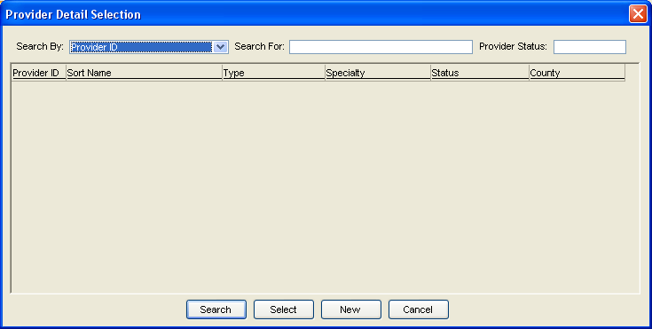

NEW MEXICO OMNICAID MMIS PROVIDER SUBSYSTEM
WINDOW EXHIBIT
PROVIDER DETAIL FUNCTIONAL GROUP
PROVIDER SELECTION WINDOW

Field Name | Table  Column Name | Table Name | Format | Prot (A,C,N) | Req  (A,C,N) | Std Edits | Specifications | Note  Ref
Search By | P_ID  P_NTRPRS_ID  P_LIC_CERT_NUM  P_SSN_NUM  P_FED_TAX_ID_NUM  P_UPIN_NUM  P_SORT_NAM  P_DBA_NAM  P_MCARE_NUM  P_NPI_ID  P_NABP_NUM | P_PROV_TB  P_PROV_TB  P_LIC_CERT_TB  P_PROV_TB  P_PROV_TB  P_PROV_TB  P_PROV_TB  P_PROV_TB  P_MCARE_TB  P_PROV_TB  P_PROV_TB | X(20) | N | N | N/A
Search For | N/A | N/A | N/A | N | C | N/A | Required when a search by value is selected.
Provider ID | P_ID | P_PROV_TB | X(8) | A | N/A | N/A
Sort Name | P_SORT_NAM | P_PROV_TB | X(35) | A | N/A | N/A
Type | N/A | N/A | X(10) | A | N/A | N/A | Contains the short description of P_TY_CD from the valid value table 204.
Specialty | N/A | N/A | X(10) | A | N/A | N/A | Contains the short description of P_SPECL_CD from the valid value table 2653.
Status | N/A | N/A | X(10) | A | N/A | N/A | Contains the short description of P_ENROL_STAT_TY_CD from the valid value table 189.
County | N/A | N/A | X(10) | A | N/A | N/A | Contains the short description of P_CNTY_CD from the valid value table 2639.

LEGEND: For Prot and Req: A = Always For Std Edits: D = Date Edit V = Valid Value Edit
C = Conditionally N = Numeric Edits S = System Generated
N = Never

NEW MEXICO OMNICAID MMIS PROVIDER SUBSYSTEM
WINDOW SPECIFICATION
PROVIDER DETAIL FUNCTIONAL GROUP
NAME/ADDRESS TAB PAGE

Window Name: W_PROV_DTL/UO_TABPG_PROV_NAM_ADDR
Description:
The Provider Name/Address Tab Page is used to enroll providers and update provider data. This tab page accommodates up to three address types: billing address, mail-to address, and location address. Both voice and FAX telephone numbers may be entered for each address. The user can access provider-specific rates information from this window, using the Go To feature.

Special Security Requirements:
N/A

Presentation Sequence(s): for Previous Provider:
Effective Date Descending.

Remarks:
The change of Ownership group box is normally protected. When an enrollment status is added to indicate change of ownership, the New Provider ID checkbox becomes unprotected. When the user checks this box, blank windows appear to enable entering new ownership information. When the new owner’s information is saved, the system assigns a new provider ID. Once this is done, the provider ID of the previous owner and the current date will appear in the Change of Ownership list box.

NEW MEXICO OMNICAID MMIS PROVIDER SUBSYSTEM
WINDOW LAYOUT
PROVIDER DETAIL FUNCTIONAL GROUP
NAME/ADDRESS TAB PAGE

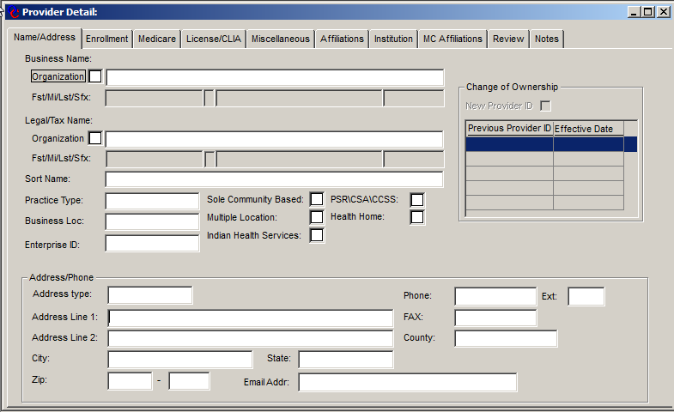

NEW MEXICO OMNICAID MMIS PROVIDER SUBSYSTEM
WINDOW EXHIBIT
PROVIDER DETAIL FUNCTIONAL GROUP
PROVIDER NAME/ADDRESS TAB PAGE

Field Name | Table  Column Name | Table Name | Format | Prot (A,C,N) | Req  (A,C,N) | Std Edits | Specifications | Note  Ref
Business Name:
Organization | P_NAM_ORG_IND | P_PROV_TB | X(1) | N | A | N/A | Indicates whether the provider is an organization or individual. This box will be checked for an organization
Business Name | P_NAM | P_PROV_TB | X(45) | C | C | N/A | Legal name of an organization provider. | 2,5
Fst/Mi/Lst/Sfx | P_FST_NAM | P_PROV_TB | X(15) | C | C | N/A | Legal first name of an individual provider. | 2
 | P_MI_NAM | P_PROV_TB | X(1) | C | C | N/A | Legal middle name of an individual provider. | 2
 | P_LAST_NAM | P_PROV_TB | X(35) | C | C | N/A | Legal last name of an individual provider. | 2
 | P_SFX_NAM | P_PROV_TB | X10) | C | C | N/A | Legal suffix of an individual provider. | 2
Legal/Tax Name:
Organization | P_DBA_ORG_IND | P_PROV_TB | X(1) | N | A | N/A | Indicates whether the provider is an organization or individual. This box will be checked for an organization
Legal/Tax Name | P_DBA_NAM | P_PROV_TB | X(45) | N | N | N/A | Doing Business As name of the provider. Default is space. | 3,5
Fst/Mi/Lst/Sfx | P_DBA_FST_NAM | P_PROV_TB | X(15) | C | C | N/A | Doing Business As first name of an individual provider. | 3
 | P_DBA_MI_NAM | P_PROV_TB | X(1) | C | C | N/A | Doing Business As middle name of an individual provider. | 3
 | P_DBA_LAST_NAM | P_PROV_TB | X(35) | C | C | N/A | Doing Business As last name of an individual provider. | 3
 | P_DBA_SFX_NAM | P_PROV_TB | X(10) | C | C | N/A | Doing Business As name suffix of an individual provider. | 3
Sort Name | P_SORT_NAM | P_PROV_TB | X(45) | N | A | N/A | The name used for sorting provider name. | 5
Practice Type | N/A | N/A | X(14) | N | A | V | Contains P_PRACT_TY_CD from  P_PROV_TB and its short description from the valid value table 203.
Business Loc | N/A | N/A | X(14) | N | A | V | Contains P_LOCN_CD from P_PROV_TB and its short description from the valid value table 190.
Enterprise ID | P_NTRPRS_ID | P_PROV_TB | X(08) | N | N | N/A | Can be used to link providers.  The default is provider ID.
Sole Community  Based | P_SOLE_COMM_ IND | P_PROV_TB | X(1) | N | N | N/A | Values in the table are “Y” or “N”. “N” is the default. A check in the checkbox indicates the value is “Y”.
Multiple Locations | P_MULTI_LOCN_IND | P_PROV_TB | X(1) | N | N | N/A | Values in the table are “Y” or “N”. “N” is the default. A check in the checkbox indicates the value is “Y”.
Indian Health Services | P_IHS_IND | P_PROV_TB | X(1) | N | N | N/A | Values in the table are “Y” or “N”. “N” is the default. A check in the checkbox indicates the value is “Y”.
PSR\CSA\CCSS: | P_PSY_SOC_IND | P_PROV_TB | X(1) | N | N | N/A | Values in the table are “Y” or “N”. “N” is the default. A check in the checkbox indicates the value is “Y”.
Health Home | P_HLTH_HM_IND | P_PROV_TB | X(1) | N | N | N/A | Values in the table are “Y” or “N”. “N” is the default. A check in the checkbox indicates the value is “Y”.
Change of Ownership
New Provider ID | N/A | N/A | N/A | C | N | N/A | Unprotected only when the status of the current provider is changed to status 06 – Terminated - Change of Ownership. | 1
Previous Prov ID | P_MEMBER_P_ID | P_AFFL_TB | X(8) | A | N/A | N/A | Affiliation type will be “N” for New Owner.
Effective Date | P_AFFL_BEG_DT | P_AFFL_TB | DATE | A | N/A | N/A | Defaults to current Date when new provider ID is requested.
Address Type | N/A | N/A | X(14) | N | A | V | Contains P_ADR_TY_CD from  P_ADDR_TB and its short description from the valid value table 202. Location address type is required.
Address Line 1 | P_LINE1_AD | P_ADDR_TB | X(45) | N | C | N/A | Required for location address type, if address line 2 is blank. | 5
Address Line 2 | P_LINE2_AD | P_ADDR_TB | X(45) | N | C | N/A | Required for location address type, if address line 1 is blank. | 5
City | P_CITY_NAM | P_ADDR_TB | X(20) | N | C | N/A | Required for location address type, or if an address line is entered for Billing or Mail-to address type.
State | P_ST_CD | P_ADDR_TB | X(14) | N | C | V | Contains P_ST_CD from  P_ADDR_TB and its short description from the valid value table 2638. Required for location address type, or if an address line is entered for Billing or Mail-to address type.
Zip | P_ZIP5_CD | P_ADDR_TB | X(5) | N | C | N | Required for location address type or if an address line is entered for Billing or Mail-to address type. | 4
 | P_ZIP4_CD | P_ADDR_TB | X(4) | N | N | N | Default is spaces.
E-Mail Address | P_EMAIL_ADR_TEXT | P_ADDR_TB | X(50) | N | N | N | Default is spaces.
Phone | P_PHON_NUM | P_ADDR_TB | X(10) | N | C | N | Required for Location Address.
Phone Extension | P_PHON_EXT_NUM | P_ADDR_TB | X(5) | N | N | N | Default is spaces.
FAX | P_FAX_NUM | P_ADDR_TB | X(10) | N | N | N | Default is spaces.
County | N/A | N/A | X(15) | N | C | V | Contains P_CNTY_CD from  P_ADDR_TB and its short description from the valid value table 2639. Required for location address.

Notes:

- Checking the New Provider Check box will cause a new set of windows to be presented for data entry, with the old provider number and the current date in the Previous Provider ID list box.
- If P_NAM_ORG_IND is checked, then this provider is treated as an organization and the name is entered in the 45 byte freeform box. The name will be saved to P_NAM and P_LAST_NAM. If P_NAM_ORG_IND is not checked then this provider is treated as an individual and the name is entered into the Fst/Mi/Lst/Sfx boxes. These will be concatenated into P_NAM on the database.
- If P_DBA_ORG_IND is checked, then this provider is treated as an organization and the name is entered in the 45 byte freeform box. The name will be saved to P_DBA_NAM and P_DBA_LAST_NAM. If P_DBA_ORG_IND is not checked then this provider is treated as an individual and the name is entered into the Fst/Mi/Lst/Sfx boxes. These will be concatenated into P_DBA_NAM on the database.
- If P_ZIP5_CD is changed, the new value is copied to all rows in Provider Details’ NPI records.
- Provider Names and Address Lines updates are scanned for punctuation and special characters. When found, these characters are removed from the entry and are not saved to the database.

The Provider name is checked for the following punctuation:

- , - comma
- ; - semicolon
- : - colon
- ' - single quote
- " - quote

The address 1 and address 2 fields are checked for the following punctuation:

- , - comma
- ; - semicolon
- : - colon
- ' - single quote
- " - quote
- . - period
- \ - back slash
- ! – exclamation point

LEGEND: For Prot and Req: A = Always For Std Edits: D = Date Edit V = Valid Value Edit
C = Conditionally N = Numeric Edits S = System Generated
N = Never
NEW MEXICO OMNICAID MMIS PROVIDER SUBSYSTEM
WINDOW SPECIFICATION
PROVIDER DETAIL FUNCTIONAL GROUP
ENROLLMENT TAB PAGE

Window Name: W_PROV_DTL/UO_TABPG_PROV_ENROLL
Description:
The Enrollment Tab Page contains the application signed date and the Enrollment Status and Effective Dates, a list of programs for the provider with associated begin and end dates, as well as a number of provider identifiers, including Social Security Number (SSN), Unique Provider ID Number (UPIN), Drug Enforcement Agency (DEA) Number, National Provider ID (NPI), and NABP Number.

Special Security Requirements:
N/A

Presentation Sequence(s) for Enrollment:
Status Date Descending

Presentation Sequence(s) for Programs:
Begin Date Descending.
Presentation Sequence(s) for Specialty:
Begin Date Descending.

Presentation Sequence(s)

Remarks:
N/A

NEW MEXICO OMNICAID MMIS PROVIDER SUBSYSTEM
WINDOW LAYOUT
PROVIDER DETAIL FUNCTIONAL GROUP
ENROLLMENT TAB PAGE
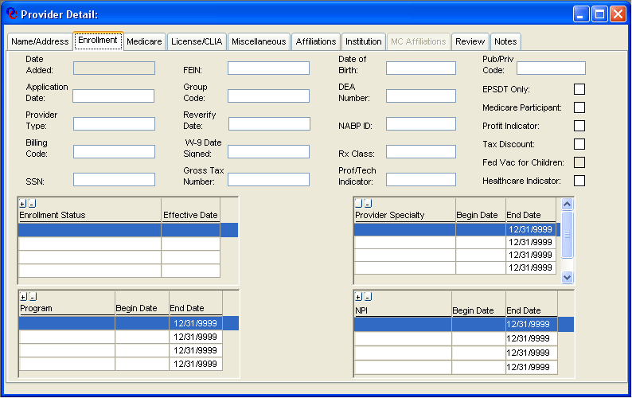

NEW MEXICO OMNICAID MMIS PROVIDER SUBSYSTEM
WINDOW EXHIBIT
PROVIDER DETAIL FUNCTIONAL GROUP
PROVIDER ENROLLMENT TAB PAGE

Field Name | Table  Column Name | Table Name | Format | Prot (A,C,N) | Req  (A,C,N) | Std Edits | Specifications | Note  Ref
Date Added | P_ADD_DT | P_PROV_TB | Date | A | A | N/A | Will be populated by the current date on the system.
Application Date | P_APPL_DT | P_PROV_TB | DATE | N | A | D | The date on the application.
Provider Type | P_TY_CD | P_PROV_TB | X(03) | N | A | V | Displays the code and its short description from the valid value table 204. | 1,2,3,4, 10
Billing Code | P_BLNG_CD | P_PROV_TB | X(01) | N | A | V | Displays the code and its short description from the valid value table 2661.  Defaults to “U”- Unrestricted. | 10
SSN | P_SSN_NUM | P_PROV_TB | X(9) | N | C | N | Required if FEIN is not entered.  Default is space. If entered, must be 9 digits long.
FEIN | P_FED_TAX_ID | P_PROV_TB | X(9) | N | C | N | Required if SSN is not entered.  Default is space. If entered, must be 9 digits long.
Group Code | P_INDIV_GRP_CD | P_PROV_TB | X(01) | N | A | V | Displays code and a short description from the valid value table 205.
Reverify Date | P_REVER_DT | P_PROV_TB | DATE | N | A | D | Required for all providers with the exception of MCOs and their Affiliates.
W-9 Date Signed | P_W9_SIGNED_DT | P_PROV_TB | DATE | N | N | D
Gross Tax  Number | P_GROSS_TAX_NUM | P_PROV_TB | X(9) | N | N | N | Default is space.
Date of Birth | P_DOB_DT | P_PROV_TB | DATE | N | C | D |  | 12
DEA Number | P_DEA_NUM | P_PROV_TB | X(11) | N | N | N | Default is space. This field can contain alpha and numeric characters. | 6
NABP ID | P_NABP_NUM | P_PROV_TB | X(11) | N | C | N | Required for pharmacies. If not a pharmacy, default is space.
Rx Class | P_PHRM_CLS_CD | P_PROV_TB | X(01) | N | N | V | Displays code and its short description from the valid value table 1615. Default is “None”.
Prof/Tech Ind | P_PROF_TECH_CD | P_PROV_TB | X(14) | N | N | V | Displays code and its short description from the valid value table 2662. | 11
Pub/Priv Code | P_PUB_PRV_CD | P_PROV_TB | X(1) | N | N | N/A | Default is 1-Private.
EPSDT Only | P_EPSDT_ONLY_IND | P_PROV_TB | X(1) | N | N | N/A | A Yes or No indicator. Default is “N”  A check in the box indicates a value of Yes.
Medicare  Participant | P_MCARE_IND | P_PROV_TB | X(1) | N | N | N/A | A Yes or No indicator. Default is “N”.  A check in the box indicates a value of Yes. | 7
Profit Indicator | P_PROFIT_IND | P_PROV_TB | X(1) | N | N | N/A | A Yes or No indicator. Default is “Y”.  A check in the box indicates a value of Yes.
Tax Discount | P_TAX_DISCT_IND | P_PROV_TB | X(1) | N | N | N/A | A Yes or No indicator. Default is “N”.  A check in the box indicates a value of Yes.
Fed Vac for  Children | P_FED_ VAC_CHLD_ IND | P_PROV_TB | X(1) | A | N | N/A | This is a Yes or No indicator and is reserved for future use.
Healthcare Indicator | P_HLTHCARE_IND | P_PROV_TB | X(1) | A | N | N/A | A Yes or No indicator. Default is “N”.  A check in the box indicates a value of Yes. | 9
Enrollment Status | P_ENROL_STAT_TY_CD | P_ENROL_STAT_TB | X(02) | N | A | V | Displays the code and its short description from the valid value table 189. New statuses and dates may be added or deleted. Only one status may be added for a specific status effective date. | 2
Effective Date | P_STAT_EFF_DT | P_ENROL_STAT_TB | DATE | N | A | D
Program | P_PROG_CD | P_PROG_TB | X(01) | N | A | V | Displays the code and its short description from the valid value table 1620. | 3
Program Begin  Date | P_PROG_BEG_DT | P_PROG_TB | DATE | N | A | D | Required if Program Code is entered.
Program End Date | P_PROG_END_DT | P_PROG_TB | DATE | N | A | D | Default is “9999-12-31” for DB2 processing. This value will be moved to the window as soon as a program code is typed in. If a status of “terminated” is added, the status effective date will be moved to this date.
Provider Specialty | P_SPECL_CD | P_SPECL_TB | X(03) | N | C | V | Displays the code and its short description from the valid value table 2653. Required if the provider type requires a specialty code. | 8
Begin Date | P_SPECL_BEG_DT | P_SPECL_TB | DATE | N | C | D | Required if the provider type requires a specialty code.
End Date | P_SPECL_END_DT | P_SPECL_TB | DATE | N | C | D | Required if the provider type requires a specialty code. This will default to  “12-31-9999”.
NPI | P_NPI_ID | P_NPI_XMTCH_ | X(16) | N | C | V | Required if the Current Enrollment Status is 60-Active or 70-None (MCO) and Healthcare Indicator is checked. | 9, 10
Begin Date | P_NPI_BEG_DT | P_NPI_XMTCH_ | DATE | N | Y | D | Required if the provider requires a NPI.
End Date | P_NPI_END_DT | P_NPI_XMTCH_ | DATE | N | Y | D | Required if the provider requires a NPI. This will default to  “12-31-9999”. | 12

Notes:

- If a provider types is 701, 702, 703, 704 and a Managed Care plan exists for that provider, the provider type cannot be changed, unless it is being changed to a 701, 702, 703 or 704.
- The enrollment status cannot be changed if the provider type is 701 thru 705 if they have a plan with an end date greater than the status effective date.
- Provider types 701 thru 705 must have a program of “MAD” only.
- Provider type 705 may not be changed if a Managed Care plan is open for that provider.
- Removed with Cenntennial Care. This is now no longer applicable since Encounter Only providers demographic information can now be updated through online updates.
- DEA Number is validated for a length of 9, valid first and second characters, and a check digit. The only valid entry for a dummy DEA Number is ‘AB9999998’.
- The Medicare Participant checkbox is not tied to the information on Medicare Tab.
- The list box for specialties will only display the specialties that are valid for the provider type entered. If no specialties are valid, the specialty group box will be protected.
- NPI entries are validated for length (10) , NPI check digit and date overlap. The same NPI cannot exist for two providers with the same tax ID or SSN, same provider type, same location zip code and same or overlapping effective dates. In addition, the same NPI cannot exist under different tax IDs or SSNs with overlapping effective dates.

- When the Provider Status is changed to “terminated” (status 01, 02, 03, 04, 05, 06, 07, 08, 09, 10, 11, 12, or 13), the system sets current Provider NPI span End Date to equal the final date of the provider’s “Active” status (60) on the Enrollment tab in the Provider Detail window. If the most current Provider NPI span End Date is not open-ended (not equal 12/31/9999), the system provides an informational message box which states, “NPI is already end dated and will not be systematically end dated.” The update will be saved without systematically updating the Provider NPI End Date.

- Provider Types 351, 352, and 353 may be any Prof/Tech Indicator code, but only these three provider types may be assigned ‘T’. When nothing is entered in the field, the Prof/Tech Indicator code is defaulted to ‘T’, if the provider type is 351, 352, or 353, or to ‘P’ if the provider type is any other provider type.

- 1) For new providers the Date of Birth is required if Practice Type equals Individual or Sole Proprietor 2) For existing providers the DOB is required if: A Practice Type is changed to Individual or Sole Proprietor
B Practice Type is Individual or Sole Proprietor and change is made on the Enrollment tab.
C If Practice Type is already Individual or Sole Proprietor and changes are made on any tab other than the Enrollment tab the DOB is not required.

- NPI Effective end date must be greater than or equal to any current active or pended Enrollment status. If the NPI effective date is less that the most recent active or pended Enrollment status date, an error will be displayed to the user and they will not be able to save the update.

__________________________________________________________________________________________________________________________

LEGEND: For Prot and Req: A = Always For Std Edits: D = Date Edit V = Valid Value Edit
C = Conditionally N = Numeric Edits S = System Generated
N = Never
NEW MEXICO OMNICAID MMIS PROVIDER SUBSYSTEM
WINDOW SPECIFICATION
PROVIDER DETAIL FUNCTIONAL GROUP
MEDICARE TAB PAGE

Window Name: W_PROV_DTL/UO_TABPG_MEDICARE
Description:
The Provider Medicare Tab Page is used to inquire into and update provider Medicare cross-reference data. This window also displays the name, address, and telephone number information for the Medicare carrier.

Special Security Requirements:
N/A

Presentation Sequence(s) for Medicare Provider:
Begin Date Ascending.

Remarks:
To go to the Medicare Carrier functional group the user may click on GoTo on the action bar.

NEW MEXICO OMNICAID MMIS PROVIDER SUBSYSTEM
WINDOW LAYOUT
PROVIDER DETAIL FUNCTIONAL GROUP
MEDICARE TAB PAGE
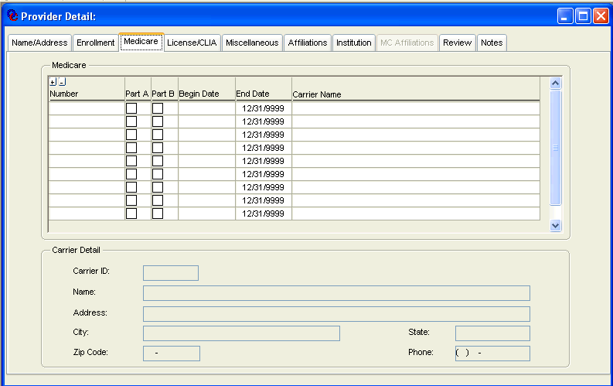

NEW MEXICO OMNICAID MMIS PROVIDER SUBSYSTEM
WINDOW EXHIBIT
PROVIDER DETAIL FUNCTIONAL GROUP
PROVIDER MEDICARE CARRIER TAB PAGE

Field Name | Table  Column Name | Table Name | Format | Prot  (A,C,N) | Req  (A,C,N) | Std Edits | Specifications | Note  Ref
Medicare  Number | P_MCARE_NUM | P_MCARE_TB | X(12) | N | C | N/A | Required if other fields are entered.
Part A | P_MCARE_PART_A_IND | P_MCARE_TB | X(01) | N | C | N/A | This is a Yes or No flag. Required if other fields are entered and Part B is not Yes.
Part B | P_MCARE_PART_B_IND | P_MCARE_TB | X(01) | N | C | N/A | Required if other fields are entered and Part A is not Yes.
Begin Date | P_MCARE_BEG_DT | P_MCARE_TB | DATE | N | C | D | Required if Medicare number is entered.
End Date | P_MCARE_END_DT | P_MCARE_TB | DATE | N | N | D | Will default to “9999-12-31”.
Carrier ID | P_MC_CARR_ID/P_MC_CARR_NAM | P_MCARE_CARR_TB | X(10)/  X(50) | A | N | N/A | The user can click on this field and choose from a drop-down list of carriers on the system.
Carrier/Detail  Name | P_MC_CARR_NAM | P_MCARE_CARR_TB | X(50) | A | N/A | N/A
Address | P_MC_CARR_AD | P_MCARE_CARR_TB | X(50) | A | N/A | N/A
City | P_MC_CARR_CITY_NAM | P_MCARE_CARR_TB | X(20) | A | N/A | N/A
State | N/A | N/A | X(15) | A | N/A | N/A
Zip Code | P_MC_CARR_ZIP_CD | P_MCARE_CARR_TB | X(9) | A | N/A | N/A
Phone | P_MC_CARR_PHON_NUM | P_MCARE_CARR_TB | X(10) | A | N/A | N/A
_______________________________________________________________________________________________________________________________

LEGEND: For Prot and Req: A = Always For Std Edits: D = Date Edit V = Valid Value Edit
C = Conditionally N = Numeric Edits S = System Generated
N = Never

NEW MEXICO OMNICAID MMIS PROVIDER SUBSYSTEM
WINDOW SPECIFICATION
PROVIDER DETAIL FUNCTIONAL GROUP
LICENSE/CLIA TAB PAGE

Window Name: W_PROV_DTL\UO_TABPG_PROV_LIC_CLIA
Description:
The License/CLIA portion of this tab page allows updates and additions to the provider’s license and certification data. Information on this tab page includes the License Number, effective and expiration dates, the license type, the State issuing the license, the board that issued the license, a restriction code, and a check box showing if the license was verified. The CLIA section contains the provider’s CLIA certification number and certification type, effective and expiration dates.

Special Security Requirements:
N/A

Presentation Sequence(s) for License/Certification:
License Effective Date Descending.

Presentation Sequence(s) for CLIA Number:
Effective Date Descending.

Remarks:
If a license is being renewed, the procedure will be to add a new row. The verified column in the new row will default to ‘N’.

NEW MEXICO OMNICAID MMIS PROVIDER SUBSYSTEM
WINDOW LAYOUT
PROVIDER DETAIL FUNCTIONAL GROUP
LICENSE/CLIA TAB PAGE

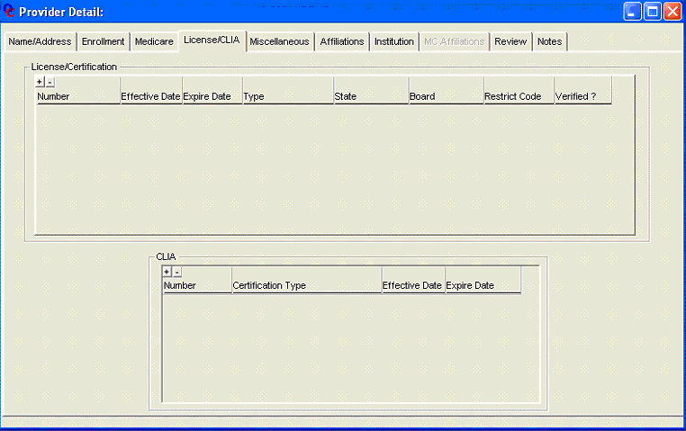

NEW MEXICO OMNICAID MMIS PROVIDER SUBSYSTEM
WINDOW EXHIBIT
PROVIDER DETAIL FUNCTIONAL GROUP
LICENSE/CLIA TAB PAGE

Field Name | Table  Column Name | Table Name | Format | Prot (A,C,N) | Req  (A,C,N) | Std Edits | Specifications | Note  Ref
License/Certification |  |  |  |  |  |  | Grouping
Number | P_LIC_CERT_NUM | P_LIC_CERT_TB | X(15) | N | C | N/A |  | 2
Effective Date | P_LIC_EFF_DT | P_LIC_CERT_TB | DATE | N | C | D |  | 2
Expire Date | P_LIC_EXPIR_DT | P_LIC_CERT_TB | DATE | N | C | D |  | 2
Type | N/A | N/A | X(15) | N | C | V | Contains P_LIC_CERT_CD from  P_LIC_CERT_TB and its short description from the valid value table 1503. | 2
State | N/A | N/A | X(13) | N | C | V | Contains P_ST_CD from  P_LIC_CERT_TB and descriptions  from the valid value table 2638. | 2
Board | N/A | N/A | X(08) | N | C | V | Contains P-LIC-BRD_NUM from P-  LIC_CERT_TB and a short description from the valid value table 1568. | 2
Restrict Code | N/A | N/A | X(14) | N | N | V | Contains P_LIC_RSTRCT_CD from  P_LIC_CERT_TB and its short description from the valid value table 1571. The default is A-Lic-Active.
Verified? | P_LIC_VRFY_IND | P_LIC_CERT_TB | X(01) | N | N | N/A | “Y” or “N.” Default is “N”. A check in the checkbox indicates the value is “Y”.
CLIA |  |  |  |  |  |  | Grouping
Number | P_CLIA_NUM | P_CLIA_CERT_TB | X(10) | N | C | N/A | This is manually input by the user. | 1
Certification Type | N/A | N/A | X(14) | N | C | V | Contains P_CLIA_CERT_TY_CD from P_CLIA_CERT_TB and its short description from the valid value table 2651. Required if CLIA ID is entered. | 1
Effective Date | P_CLIA_CERT_EFF_DT | P_CLIA_CERT_TB | DATE | N | C | D | This is from the CLIA Interface, but may be entered manually. Required if CLIA ID is entered. | 1
Expire Date | P_ CERT_EXPIR_DT | P_CLIA_CERT_TB | DATE | N | C | D | This is from the CLIA Interface but may be entered manually. Required if CLIA ID is entered. | 1

Notes:

- The CLIA data can be entered manually. Each month when the interface file is received, the data will be overlaid. If one field in the CLIA group box is entered, all others must be entered.
- If Number, effective date, expire date, type, state or board is entered, all the other fields in this group must be entered.

_______________________________________________________________________________________________________________________________

LEGEND: For Prot and Req: A = Always For Std Edits: D = Date Edit V = Valid Value Edit
C = Conditionally N = Numeric Edits S = System Generated
N = Never

NEW MEXICO OMNICAID MMIS PROVIDER SUBSYSTEM
WINDOW SPECIFICATION
PROVIDER DETAIL FUNCTIONAL GROUP
MISCELLANEOUS TAB PAGE

Window Name: W_PROV_DTL/UO_TABPG_PROV_MISC
Description:
The Miscellaneous Tab Page contains directions for the print of suspended claims, remittance advices and bulletins. It also contains EFT data, dispensing fees for pharmacy providers, Billing Media and provider languages.

Special Security Requirements:
The EMC (Billing) password field is updateable only for specific users.

Presentation Sequence(s) for Billing Media:
Ascending.

Presentation Sequence(s) for Dispensing Fees:
Effective Date Descending

Presentation Sequence(s) for Languages:
Ascending

Remarks:
N/A

NEW MEXICO OMNICAID MMIS PROVIDER SUBSYSTEM
WINDOW LAYOUT
PROVIDER DETAIL FUNCTIONAL GROUP

MISCELLANEOUS TAB PAGE

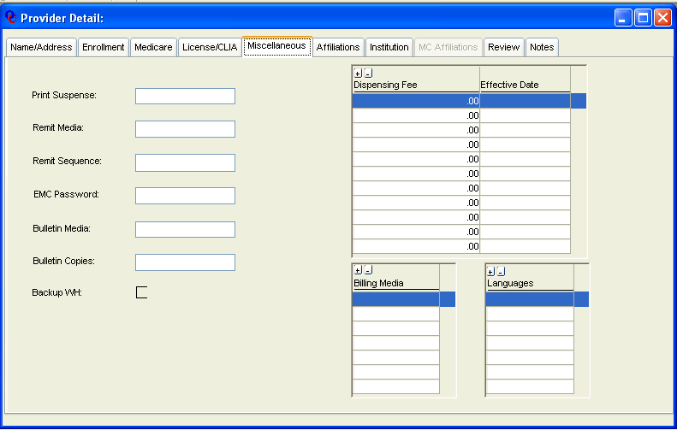

NEW MEXICO OMNICAID MMIS PROVIDER SUBSYSTEM
WINDOW EXHIBIT
PROVIDER DETAIL FUNCTIONAL GROUP
MISCELLANEOUS TAB PAGE

Field Name | Table  Column Name | Table Name | Format | Prot (A,C,N) | Req  (A,C,N) | Std Edits | Specifications | Note  Ref
Print Suspense | N/A | N/A | X(14) | N | N | V | Contains P_RA_PRT_SUSP_CD from P_PROV_TB and its short description from the valid value table 179. The default is “Print All”
Remit Media | N/A | N/A | X(14) | N | N | V | Contains P_RA_MEDM_CD from  P_PROV_TB and its short description from the valid value table 1621. Default is W for Web.
Remit Sequence | N/A | N/A | X(14) | N | N | V | Contains P_RA_SORT_SEQ_CD from P_PROV_TB and its short description from the valid value table 178. Default is “Prov Num”.
EMC Password | P_EMC_PSWD_DAT | P_PROV_TB | X(8) | C | N | N/A | This field will only be updateable by users with EMC password authority. Default is space.
Bulletin Media | N/A | N/A | X(14) | N | N | V | Contains P_BLLTN_MEDM_CD from P_PROV_TB and its short description from the valid value table1525. Default is “None”.
Bulletin Copies | P_BLLTN_COPY_NUM | P_PROV_TB | 9(5) | N | N | N | Default is zero.
EFT Acct Num | P_EFT_ACCT_NUM | P_ PROV_TB | X(15) | N | N | N | Default is space.
Bank ID Num | P_BIN_NUM | P_ PROV_TB | X(9) | N | N | N | Default is space.
Backup WH | P_BKUP_WHOLD_IND | P_PROV_TB | X(1) | A | N/A | N/A | This field is reserved for future use.  Provider Financial may update it in the future. Default is “No”.
Dispensing Fee | P_DISP_FEE_AMT | P_DISP_FEE_TB | S9(5)V99 | N | C | N | It must be entered if the Effective Date below is entered.
Effective Date | P_DISP_ EFF_DT | P_DISP_FEE_TB | Date | N | C | D | This must be entered if dispensing fee above is entered.
Billing Media | N/A | N/A | X(10) | N | N | V | Contains P_BLNG_MEDM_CD from P_BLNG_MEDM_TB and its short description from the valid value table 2650
Languages | N/A | N/A | X(14) | N | N | V | Contains P_LANG_CD from  P_LANG_TB and its short description from the valid value table 196.

________________________________________________________________________________________________________________________________

LEGEND: For Prot and Req: A = Always For Std Edits: D = Date Edit V = Valid Value Edit
C = Conditionally N = Numeric Edits S = System Generated
N = Never
NEW MEXICO OMNICAID MMIS PROVIDER SUBSYSTEM
WINDOW SPECIFICATION
PROVIDER DETAIL FUNCTIONAL GROUP
AFFILIATIONS TAB PAGE

Window Name: W_PROV_DTL/UO_TABPG_PROV_AFFL
Description:
The Affiliations Tab Page enables identification of all members of a group, as well as identification of all groups with which an individual provider is affiliated, and the effective dates of each affiliation. Providers that represent a group or a member of a group must have their own provider ID. The user can enter four types of affiliations for a provider, while a fifth type is created automatically by MMIS. The user may inquire on affiliations by choosing an affiliation type from the drop down data window and by designating an affiliation direction of either List Members or List Groups. The affiliation types that can be added by the user are Billing Agent affiliation (one or more providers billed by one agent), Group practice affiliation (one or more providers in one group practice), and Association affiliation (one or more individual nurse practitioners to one doctor). The user can also add a Duplicate affiliation (one or more denied provider IDs to one provider ID that is kept). A Duplicate affiliation would be created manually when the user found two or more provider IDs for the same provider. The user would deny all of the providers except one, go to the affiliation tab of the provider ID that is kept and enter the provider IDs of the denied providers as members. The provider ID that is kept would be considered the group and the denied providers would be the members. The last type of affiliation is New Owner and is set up by the MMIS system automatically when a change of ownership is initiated on the Name and Address tab. The New Owner is considered the group, and the old is the member.

To enter affiliation information the user searches for the provider ID of the group, billing agent, association or the duplicate that was kept, then goes to the Provider Affiliations Window and adds members. Members are always added to groups; groups are not added to members.

When inquiring, if the user sets the affiliation direction to “List Group”, this window lists the groups of which a provider is a member. Conversely, when the user sets the affiliation direction to “List Member”, this window lists the members of the group provider. It should be noted that a provider may be a member of more than one group and may have one or more affiliation types. A provider may also be a member of a group and themselves be defined as a group for members under them. For example, a doctor may be a member of a group practice. The same doctor can have an affiliation type of association with nurse practitioners as members.
Special Security Requirements:
N/A
Presentation Sequence(s) for Affiliations:
Begin Date Descending
Provider ID Ascending.

NEW MEXICO OMNICAID MMIS PROVIDER SUBSYSTEM
WINDOW LAYOUT
PROVIDER DETAIL FUNCTIONAL GROUP

AFFILIATION TAB PAGE
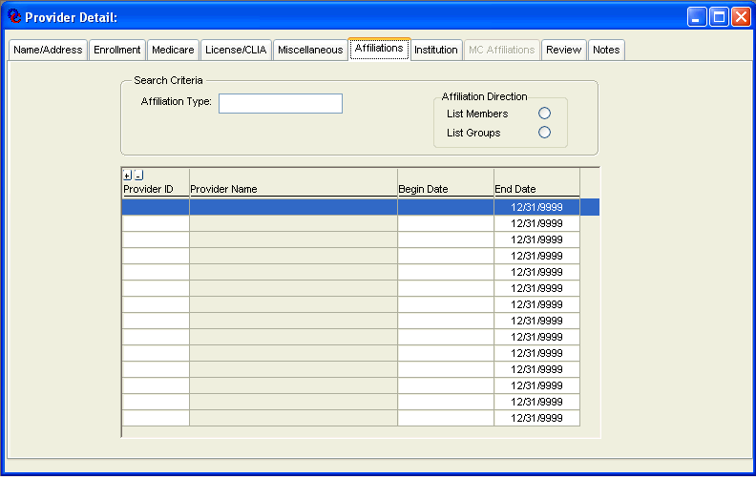
NEW MEXICO OMNICAID MMIS PROVIDER SUBSYSTEM
WINDOW EXHIBIT
PROVIDER DETAIL FUNCTIONAL GROUP
AFFILIATIONS TAB PAGE

Field Name | Table  Column Name | Table Name | Format | Prot  (A,C,N) | Req  (A,C,N) | Std Edits | Specifications | Note  Ref
Affiliation Type | N/A | N/A | X(15) | N | A | V | Contains P_AFFL_TY_CD from  P_AFFL_TB and its short description from the valid value table 195.
Affiliation  Direction | N/A | N/A | N/A | N | A | N/A
Provider ID | P_ID | P_PROV_TB | X(8) | N | C | N | Must be valid provider ID. Required if begin date is entered.
Provider Name | P_NAM | P_PROV_TB | X(35) | A | N/A | N/A |  | Will be gray on window
Begin Date | P_AFFL_BEG_DT | P_AFFL_TB | DATE | N | C | D | Required if provider number is entered. Format is MM/DD/CCYY.
End Date | P_AFFL_END_DT | P_AFFL_TB | DATE | N | C | D | Format is MM/DD/CCYY. Required if Begin Date is entered.

________________________________________________________________________________________________________________________________

LEGEND: For Prot and Req: A = Always For Std Edits: D = Date Edit V = Valid Value Edit
C = Conditionally N = Numeric Edits S = System Generated
N = Never

NEW MEXICO OMNICAID MMIS PROVIDER SUBSYSTEM
WINDOW SPECIFICATION
PROVIDER DETAIL FUNCTIONAL GROUP
INSTITUTION TAB PAGE

Window Name: W_PROV_DTL/UO_TABPG_PROV_INST
Description:
The Institution Tab Page contains data relevant to institutional provider types, such as nursing homes, hospitals, and community health centers. It includes bed data, facility type, and nursing facility class, cost settlement date and fiscal month end.

Special Security Requirements:
N/A

Presentation Sequence(s) for Disproportionate Share: Begin
Date Descending.

Presentation Sequence(s) for Bed Data:
Effective Date Descending.

Remarks:
N/A

NEW MEXICO OMNICAID MMIS PROVIDER SUBSYSTEM
WINDOW LAYOUT
PROVIDER DETAIL FUNCTIONAL GROUP
INSTITUTION TAB PAGE

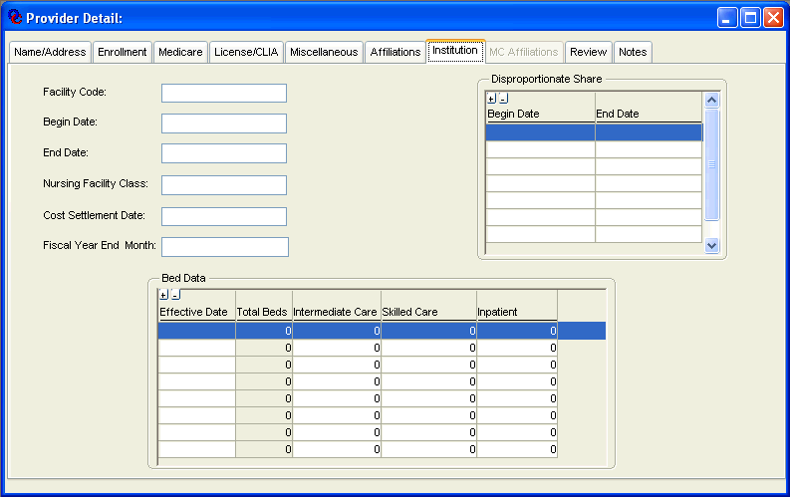

NEW MEXICO OMNICAID MMIS PROVIDER SUBSYSTEM
WINDOW EXHIBIT
PROVIDER DETAIL FUNCTIONAL GROUP
INSTITUTION TAB PAGE

Field Name | Table  Column Name | Table Name | Format | Prot  (A,C,N) | Req  (A,C,N) | Std Edits | Specifications | Note  Ref
Facility Code | N/A | N/A | X(16) | N | N | V | Contains P_FACI_TY_CD from  P_PROV_TB and its short description from the valid value table 1558. Default is “N-A”.
Begin Date | P_FACI_BEG_DT | P_PROV_TB | DATE | C | N | D | Protected unless facility code selected. Default is 01/01/0001.
End Date | P_FACI_END_DT | P_PROV_TB | DATE | C | N | D | Protected unless facility code selected. Begin Date must be entered. Default is “12/31/9999”.
Nursing Facility Class | N/A | N/A | X(14) | N | N | V | Contains P_NF_CLS_CD from  P_PROV_TB and its short description from the valid value table 1591. Default is “None”.
Cost Settlement Date | P_COST_STTLMT_DT | P_PROV_TB | DATE | N | N | D | Default is 01/01/0001 for DB2 Processing.
Fiscal Year End Month | N/A | N/A | X(13) | N | N | V | Contains number of month and short and long name of month (which are the same). This is derived from P_FSCL_END_MO_NUM in  P_PROV_TB and valid value table 2675.
Disproportionate Share Begin Date | P_DISP_SHR_BEG_DT | P_DISP_SHR_TB | DATE | N | N | D
End Date | P_DISP_SHR_END-DT | P_DISP_SHR_TB | DATE | N | N | D | If begin date is entered, defaults to  “12/31/9999”.
Bed Data Effective Date | P_NUM_BED_EFF_DT | P_NUM_BED_TB | DATE | N | C | D | Required if bed data entered. Format is MM/DD/CCYY.
Total Beds | N/A | N/A | 9(5) | A | N/A | N/A | Calculated by adding intermediate, skilled, and inpatient number of beds.
Intermediate Care | P_INTR_BED_NUM | P_NUM_BED_TB | 9(5) | N | N | N |  | 1
Skilled Care | P_SKILL_BED_NUM | P_NUM_BED_TB | 9(5) | N | N | N |  | 1
Inpatient | P_IP_BED_NUM | P_NUM_BED_TB | 9(5) | N | N | N |  | 1

Notes:

- One of these fields must be filled in if bed effective date is entered.
_______________________________________________________________________________________________________________________

LEGEND: For Prot and Req: A = Always For Std Edits: D = Date Edit V = Valid Value Edit
C = Conditionally N = Numeric Edits S = System Generated
N = Never
NEW MEXICO OMNICAID MMIS PROVIDER SUBSYSTEM
WINDOW SPECIFICATION
PROVIDER DETAIL FUNCTIONAL GROUP
MC AFFILIATIONS TAB PAGE

Window Name: W_PROV_DTL/UO_TABPG_PROV_MC_AFF
Description:
All the information displayed is from the Provider Network Affiliation Interfaces from the Managed Care
Organizations and can be updated through online updates since Centennial Care Phase 1 has been implemented (July 2013). If the provider being processed is the MCO, the tab page lists information about providers within the MCO. (These providers will be referred to as “member” providers.) If the provider being processed is a member provider, the tab page lists the MCOs that the member provider is affiliated with. This tab page also serves as a cross-reference between the 15-character ID that the MCO assigns the member provider and the Provider ID assigned to the member provider by Medicaid.

Special Security Requirements:
N/A

Presentation Sequence(s):
If the provider ID on the top line of the window is a member of an MCO, the sequence will be by MCO Provider ID

Presentation Sequence(s):
If the provider ID on the top line of the window is an MCO, the sequence will be by Member Provider ID
Member

Remarks:
The MC Affiliation tab will be only be unprotected if the billing code of the provider being processed is “Encounter Only” or “MCO.” As of 07/01/2013, the MC Affiliation tab is unprotected since FFS providers can also be an MCO provider under the new Centennial Care provider structure.

NEW MEXICO OMNICAID MMIS PROVIDER SUBSYSTEM
WINDOW LAYOUT
PROVIDER DETAIL FUNCTIONAL GROUP
MC AFFILIATIONS TAB PAGE

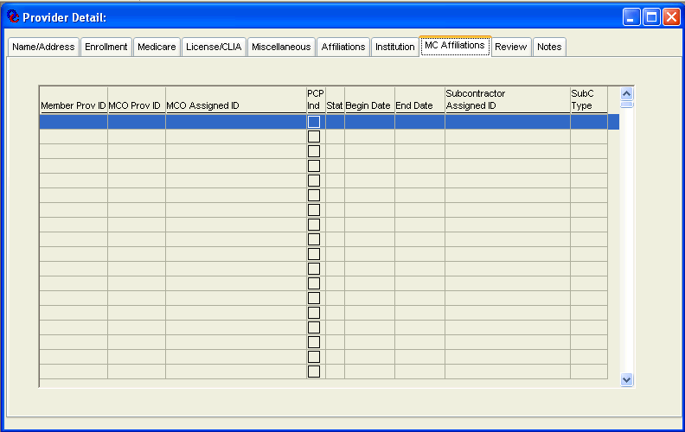

NEW MEXICO OMNICAID MMIS PROVIDER SUBSYSTEM
WINDOW EXHIBIT
PROVIDER DETAIL FUNCTIONAL GROUP
PROVIDER MC AFFLIATIONS TAB PAGE

Field Name | Table  Column Name | Table Name | Format | Prot  (A,C,N) | Req  (A,C,N) | Std Edits | Specifications | Note  Ref
Member Provider ID | P_ MEMBER_P_ID | P_MC_AFFL_X_TB | X(8) | A | N | N/A
MCO Provider ID | P_MCO_P_ID | P_MC_AFFL_X_TB | X(8) | A | N | N/A | 1
MCO Assigned ID | P_MCO_ASGN_ID | P_MC_AFFL_X_TB | X(15) | A | N | N/A
PCP Ind | P_PCP_IND | P_MC_AFFL_X_TB | X(1) | A | N | N/A
Stat | P_CNTRCT_STAT_CD | P_MC_AFFL_X_TB | X(2) | A | N | N/A
Begin Date | P_CNTRCT_STAT_B_DT | P_MC_AFFL_X_TB | Date | A | N | N/A
End Date | P_CNTRCT_STAT_E_DT | P_MC_AFFL_X_TB | Date | A | N | N/A
Subcontractor Assigned ID | P_SUB_CNTRCT_ ID | P_MC_AFFL_X_TB | X(15) | A | N | N/A
SubC Type | P_SUB_CNTRCT_TY_CD | P_MC_AFFL_X_TB | X(2) | A | N | N/A
____________________________________________________________________________________________________________________________

Notes:

- If the Billing Code is not equal to ‘E’ or ‘M’, compare the entered MCO Provider ID to the values contained on System List 0501 (new System List to be added). If the entered MCO Provider ID is not on the list, then then display error message, “Invalid Centennial Care MCO” If the entered MCO Provider ID is on the list but has contract status dates not within the list effective dates, then display error message, “Invalid Centennial Care MCO”.
If the Billing Code is equal to ‘E’ or ‘M’ and the current Enrollment Status Code = ‘70’ and the Enrollment Status Effective Date is greater than ‘12/31/2013’, compare the entered MCO Provider ID to the values contained on System List 0501 (new System List to be added). If the entered MCO Provider ID is not on the list, then then display error message, “Invalid Centennial Care MCO” If the entered MCO Provider ID is on the list but has contract status dates not within the list effective dates, then display error message, “Invalid Centennial Care MCO”.
________________________________________________________________________________________________________________

LEGEND: For Prot and Req: A = Always For Std Edits: D = Date Edit V = Valid Value Edit
C = Conditionally N = Numeric Edits S = System Generated
N = Never

NEW MEXICO OMNICAID MMIS PROVIDER SUBSYSTEM
WINDOW SPECIFICATION
PROVIDER DETAIL FUNCTIONAL GROUP

REVIEW TAB PAGE

Window Name: W_PROV_REVIEW
Description:
The Review Tab Page is used to inquire on and update information related to providers in utilization review status. The tab page includes begin and end dates, list boxes for the selection of claims, service code ranges, and program types for review, and a grid style data window for the selection of service code ranges for review.

When first entering the window, all reviews for the provider are listed in the top grid. The user can add a review by clicking on “+”in the top grid, then entering criteria below. To inquire or change a review, the user can click on the review desired in the top grid. The information for that review will be displayed below.
Special Security Requirements:
N/A

Presentation Sequence(s) for Claim Types:
Claim type Ascending

Presentation Sequence(s) for Programs:
Program code Ascending

Presentation Sequence(s) for Service Code Range:
From Procedure Ascending

Remarks:
N/A

NEW MEXICO OMNICAID MMIS PROVIDER SUBSYSTEM
WINDOW LAYOUT
PROVIDER DETAILFUNCTIONAL GROUP
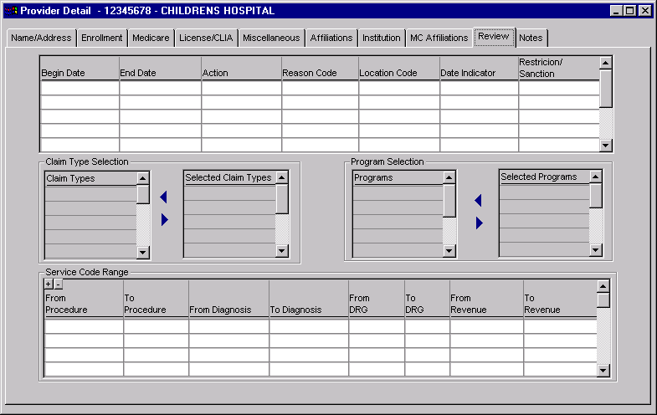
REVIEW TAB PAGE

NEW MEXICO OMNICAID MMIS PROVIDER SUBSYSTEM
WINDOW EXHIBIT
PROVIDER DETAIL FUNCTIONAL GROUP
REVIEW TAB PAGE

Field Name | Table  Column Name | Table Name | Format | Prot (A,C,N) | Req (A,C,N) | Std Edits | Specifications | Note  Ref
Review Begin Date | P_REVW_BEG_DT | P_REVW_TB | DATE | N | A | D | This field is always required if any other data is entered on the window. Format is MM/DD/CCYY.
Review End Date | P_REVW_END_DT | P_REVW_TB | DATE | N | A | D | This field is always required if the review begin date is entered. Format is MM/DD/CCYY.
Action Code | N/A | N/A | X(14) | N | A | V | This field is always required if the review begin date is entered.  Contains P_REVW_ACTN_CD From P_REVW_TB and its short description from the valid value table 1625.
Reason Code | N/A | N/A | X(15 | N | N | V | Contains P_REVW_RSN_CD  From P_REVW_TB and its short description from the valid value table 193. Default is “Unknown”.
Location Code | N/A | N/A | X(14) | N | N | V | Contains P_REVW_LOCN_CD From P_REVW_TB and its short description from the valid value table 192. Default is “None”. | Location Code
Date Indicator | N/A | N/A | X(14) | N | N | V | Contains P_REVW_DT_IND  From P_REVW_TB and its short description from the valid value table 191. Default is “Service”.
Restriction/Sanction | N/A | N/A | X(14) | N | N | V | Contains P_RSTRCT_SANC_CD  From P_REVW_TB and its short description from the valid value table 1675. Default is “Other”,
Claim Types | N/A | N/A | X(14) | N | N | V | Contains C_HDR_TY_CD from  P_RVW_CLM_TY_TB and its short description from the valid value table 141.
Selected Claim Types | N/A | N/A | X(14) | Y | N | N/A | Contains claim types selected for review. | 1
Programs | N/A | N/A | X(14) | N | N | V | Contains P_PROG_CD from  P_REVW_PROG_TB and its short description from the valid value table 1620.
Selected programs | N/A | N/A | X(14) | Y | N | N/A | Contains programs selected for review. | 1
From Procedure | P_SVC_FR_PROC_CD | P_REVW_SVC_TB | X(7) | N | N | In spec | Must be between 5 and 7 digits.  Only the first 2 digits can be alpha. | 1
To Procedure | P_SVC_THRU_PROC_CD | P_REVW_SVC_TB | X(7) | N | C | In spec | Required if From Procedure is entered. Defaults to value in From Procedure. Must be greater or equal to From Procedure. Must be between 5 and 7 digits. Only the first 2 digits can be alpha.
From Diagnosis | P_SVC_FR_DIAG_CD | P_REVW_SVC_TB | X(10) | N | N | In spec | Must be between 3 and 10 digits. For ICD 9 codes only the first digit can be alpha.. For ICD 10 codes first digit must be alpha, second digit must be numeric, remaining digits may be alphanumeric | 1,2,3
To Diagnosis | P_SVC_THRU_DIAG_CD | P_REVW_SVC_TB | X(10) | N | C | In spec | Required if From Diagnosis is entered. Defaults to the value in From Diagnosis. Must be greater or equal to From Diagnosis. Must be between 3 and 10 digits. For ICD 9 codes only the first digit can be alpha.. For ICD 10 codes first digit must be alpha, second digit must be numeric, remaining digits may be alphanumeric | 2,3
From DRG | P_SVC_FR_DRG_CD | P_REVW_SVC_TB | 9(5) | N | N | In spec | Must be between 3 and 5 digits. Must be numeric. | 1
To DRG | P_SVC_THRU_DRG_CD | P_REVW_SVC_TB | 9(5) | N | C | In spec | Required if From DRG is entered. Defaults to value in From DRG. Must be greater or equal to From DRG. Must be between 3 and 5 digits. Must be numeric.
From Revenue | P_SVC_FR_REV_CD | P_REVW_SVC_TB | X(7) | N | N | In spec | Must be between 3 and 7 digits. | 1
To Revenue | P_SVC_THRU_REV_CD | P_REVW_SVC_TB | X(7) | N | C | In spec | Required if From Revenue is entered. Defaults to value in From Revenue. Must be greater or equal to From Procedure. Must be between 5 and 7 digits.

Notes:

- One of these fields must be filled if the review begin date is entered: Selected Claim Types, Selected Programs, From Procedure, From Diagnosis, From DRG, From Revenue. For complete diagnosis formatting rules refer to Chapter 6 Reference - 06D-2wind-A-Diagnosis Code Page Window-page 29
- ICD-9 diagnosis codes can only be entered if the Effective End Date is less than the ICD-10 Effective Date on System Parameter 5050. ICD-10 diagnosis codes can only be selected if the Effective Start Date is on or after the ICD-10 Effective Date on System Parameter 5050.
- If ICD 09 diagnosis code entered and the end-date in the span is > the ICD-10 effective date maintained on System Parameter 5050, an error message is displayed and the entry is not saved. If ICD 10 diagnosis code entered and the end-date in the span is < the ICD-10 effective date maintained on System Parameter 5050, an error message is displayed and the entry is not saved.
_______________________________________________________________________________________________________________________________

LEGEND: For Prot and Req: A = Always For Std Edits: D = Date Edit V = Valid Value Edit
C = Conditionally N = Numeric Edits S = System Generated
N = Never

NEW MEXICO OMNICAID MMIS PROVIDER SUBSYSTEM
WINDOW SPECIFICATION
PROVIDER DETAIL FUNCTIONAL GROUP
NOTES TAB PAGE

Window Name: W_PROV_DTL/UO_TABPG_PROV_NOTE
Description:
The Notes Tab Page allows entry of a free-form note up to 4,000 characters.

Special Security Requirements:
N/A

Presentation Sequence(s):
N/A

Remarks:
N/A

NEW MEXICO OMNICAID MMIS PROVIDER SUBSYSTEM
WINDOW LAYOUT
PROVIDER DETAIL FUNCTIONAL GROUP
NOTES TAB PAGE
NEW MEXICO OMNICAID MMIS PROVIDER SUBSYSTEM
WINDOW EXHIBIT
PROVIDER DETAIL FUNCTIONAL GROUP
NOTES TAB PAGE

Field Name | Table  Column Name | Table Name | Format | Prot  (A,C,N) | Req  (A,C,N) | Std Edits | Specifications | Note  Ref
Provider Notes | P_NOTE_TXT | P_NOTE_TB | X(4000) | N | N | N/A

________________________________________________________________________________________________________________________________

LEGEND: For Prot and Req: A = Always For Std Edits: D = Date Edit V = Valid Value Edit
C = Conditionally N = Numeric Edits S = System Generated
N = Never

NEW MEXICO OMNICAID MMIS PROVIDER SUBSYSTEM
WINDOW SPECIFICATION
PROVIDER DETAIL FUNCTIONAL GROUP
OWNERSHIP TAB PAGE

Window Name: W_PROV_DTL/UO_TABPG_PROV_OWNERS
Description:
The Ownership Tab Page provides the ability to associate certain Owners, Managers or Employees to certain Providers.

Special Security Requirements:
N/A

Presentation Sequence(s) for Owners:
Begin Date, Tax ID Ascending

Presentation Sequence(s) for Managers/Employees:
Begin Date, SSN Ascending

Remarks:
N/A

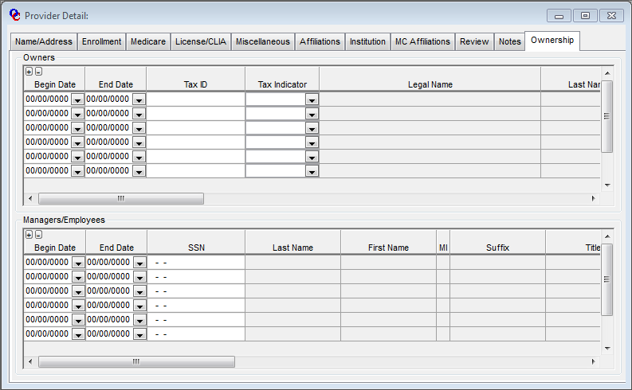

Field Name | Table  Column Name | Table Name | Format | Prot  (A,C,N) | Req  (A,C,N) | Std Edits | Specifications | Note  Ref
Begin Date | P_OWNEMP_BEG_DT | P_OWNEMP_XREF_TB | DATE | N | A | D | This field is always required if any other data is entered on the window. Format is MM/DD/CCYY.
End Date | P_OWNEMP_END_DT | P_OWNEMP_XREF_TB | DATE | N | N | D | Format is MM/DD.CCYY
Tax ID | P_OWNEMP_EINSSN_ID | P_OWNEMP_INFO_TB | X(9) | N | A | N/A | Format is ##-####### if Tax Indicator is Owner FEIN. Format is ###-##-#### if Tax Indicator is Owner SSN. | 1
Tax Indicator | P_OWNEMP_TAX_IND | P_OWNEMP_INFO_TB | X(1) | N | A | V | Valid Values:  1: Owner FEIN  2: Owner SSN  3: Employee SSN | 1
Legal Name | P_OWNEMP_DBA_NAM | P_OWNEMP_INFO_TB | X(45) | A | N | N/A
Last Name | P_OWNEMP_LAST_NAM | P_OWNEMP_INFO_TB | X(35) | A | N | N/A
First Name | P_OWNEMP_FST_NAM | P_OWNEMP_INFO_TB | X(15) | A | N | N/A
MI | P_OWNEMP_MI_NAM | P_OWNEMP_INFO_TB | X(1) | A | N | N/A
Suffix | P_OWNEMP_SFX_NAM | P_OWNEMP_INFO_TB | X(10) | A | N | N/A
Title | P_OWNEMP_TITL_NAM | P_OWNEMP_INFO_TB | X(10) | A | N | N/A
DOB | P_OWNEMP_DOB_DT | P_OWNEMP_INFO_TB | DATE | A | N | D | Format is MM/DD/YYYY
Address Line 1 | P_OWNEMP_LINE1_AD | P_OWNEMP_INFO_TB | X(45) | A | N | N/A
Address Line 2 | P_OWNEMP_LINE2_AD | P_OWNEMP_INFO_TB | X(45) | A | N | N/A
City | P_OWNEMP_CITY_NAM | P_OWNEMP_INFO_TB | X(20) | A | N | N/A
State | P_OWNEMP_ST_CD | P_OWNEMP_INFO_TB | X(2) | A | N | N/A
Zip | P_OWNEMP_ZIP5_CD | P_OWNEMP_INFO_TB | X(5) | A | N | N/A
 | P_OWNEMP_ZIP4_CD | P_OWNEMP_INFO_TB | X(4) | A | N | N/A
County | P_OWNEMP_CNTY_CD | P_OWNEMP_INFO_TB | X(2) | A | N | N/A
Country | P_OWNEMP_CNTRY_NAM | P_OWNEMP_INFO_TB | X(15) | A | N | N/A
Phone | P_OWNEMP_PHON_NUM | P_OWNEMP_INFO_TB | X(10) | A | N | N/A | Format is (###) ###-####
Fax | P_OWNEMP_FAX_NUM | P_OWNEMP_INFO_TB | X(10) | A | N | N/A | Format is (###) ###-####
Begin Date | P_OWNEMP_BEG_DT | P_OWNEMP_XREF_TB | DATE | N | A | D | This field is always required if any other data is entered on the window. Format is MM/DD/CCYY.
End Date | P_OWNEMP_END_DT | P_OWNEMP_XREF_TB | DATE | N | N | D | Format is MM/DD.CCYY
SSN | P_OWNEMP_EINSSN_ID | P_OWNEMP_INFO_TB | X(9) | N | A | N/A | Format is ###-##-####. | 2
Last Name | P_OWNEMP_LAST_NAM | P_OWNEMP_INFO_TB | X(35) | A | N | N/A
First Name | P_OWNEMP_FST_NAM | P_OWNEMP_INFO_TB | X(15) | A | N | N/A
MI | P_OWNEMP_MI_NAM | P_OWNEMP_INFO_TB | X(1) | A | N | N/A
Suffix | P_OWNEMP_SFX_NAM | P_OWNEMP_INFO_TB | X(10) | A | N | N/A
Title | P_OWNEMP_TITL_NAM | P_OWNEMP_INFO_TB | X(10) | A | N | N/A
DOB | P_OWNEMP_DOB_DT | P_OWNEMP_INFO_TB | DATE | A | N | D | Format is MM/DD/YYYY
Address Line 1 | P_OWNEMP_LINE1_AD | P_OWNEMP_INFO_TB | X(45) | A | N | N/A
Address Line 2 | P_OWNEMP_LINE2_AD | P_OWNEMP_INFO_TB | X(45) | A | N | N/A
City | P_OWNEMP_CITY_NAM | P_OWNEMP_INFO_TB | X(20) | A | N | N/A
State | P_OWNEMP_ST_CD | P_OWNEMP_INFO_TB | X(2) | A | N | N/A
Zip | P_OWNEMP_ZIP5_CD | P_OWNEMP_INFO_TB | X(5) | A | N | N/A
 | P_OWNEMP_ZIP4_CD | P_OWNEMP_INFO_TB | X(4) | A | N | N/A
County | P_OWNEMP_CNTY_CD | P_OWNEMP_INFO_TB | X(2) | A | N | N/A
Country | P_OWNEMP_CNTRY_NAM | P_OWNEMP_INFO_TB | X(15) | A | N | N/A
Phone | P_OWNEMP_PHON_NUM | P_OWNEMP_INFO_TB | X(10) | A | N | N/A | Format is (###) ###-####
Fax | P_OWNEMP_FAX_NUM | P_OWNEMP_INFO_TB | X(10) | A | N | N/A | Format is (###) ###-####

Notes:

      - When Tax ID and Tax Indicator is entered, the system does an automatic lookup on the P_OWNEMP_INFO_TB table to see if the Tax ID exists. If the Tax ID does exist, the system automatically populates the remainder of the protected fields with the Owner information. If the Tax ID does not exist in the P_OWNEMP_INFO_TB table, the system posts an edit stating that the Tax ID does not exist.
      - When Tax ID is entered, the system does an automatic lookup on the P_OWNEMP_INFO_TB table to see if the Tax ID exists. If the Tax ID does exist, the system automatically populates the remainder of the protected fields with the Owner information. If the Tax ID does not exist in the P_OWNEMP_INFO_TB table, the system posts an edit stating that the Tax ID does not exist.
________________________________________________________________________________________________________________________________

LEGEND: For Prot and Req: A = Always For Std Edits: D = Date Edit V = Valid Value Edit
C = Conditionally N = Numeric Edits S = System Generated
N = Never
3.2.2 Provider Report Request Functional Group

This functional group captures information required to request a report and enter selection parameters and a sort sequence if appropriate.

The following windows are used by the Report Request functional group:

- Provider Report Request Selection
- Provider Report Request
- Provider Report Request – 1
- Provider Report Request – 2

NEW MEXICO OMNICAID MMIS PROVIDER SUBSYSTEM
WINDOW SPECIFICATION
PROVIDER REPORT REQUEST FUNCTIONAL GROUP
PROVIDER REPORT REQUEST SELECTION WINDOW

Window Name: W_PROV_REPORT_SELECTION
Description:
The Provider Report Request Selection Window is used to display reports that have been previously requested. It allows searching for reports by a specific Requestor or Report Name. If the Report Name is selected, the user must select from the list of valid report names provided. There is also an option to list All Reports. The search results display the Report Name, the Requestor of the report, the User ID of the person who logged on and entered the request, and the Report Request Date. If a row is selected from the search results, and the report is one that can have selection criteria (Mailing Labels or Information Sheet), the Report Req 1 tab window is displayed to show criteria selected. The user can choose Report Req 2 to view the other report criteria and sort options.

To request a new report, the user presses the New button at the bottom of the window. The Report Request Window will be displayed enabling the user to choose the desired report.

Presentation Sequence:
Report Name

Special Security Requirements:
N/A

Remarks:
N/A

NEW MEXICO OMNICAID MMIS PROVIDER SUBSYSTEM
WINDOW LAYOUT
PROVIDER REPORT REQUEST FUNCTIONAL GROUP
PROVIDER REPORT REQUEST SELECTION WINDOW

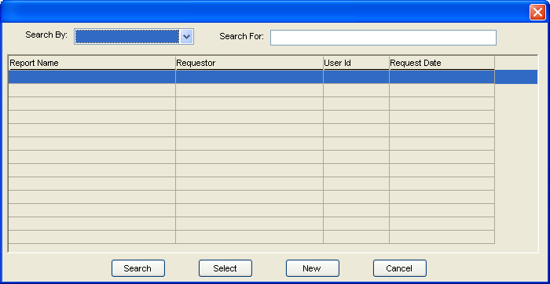

NEW MEXICO OMNICAID MMIS PROVIDER SUBSYSTEM
WINDOW EXHIBIT
PROVIDER REPORT REQUEST FUNCTIONAL GROUP
PROVIDER REPORT REQUEST SELECTION WINDOW

Field Name | Table  Column Name | Table Name | Format | Prot  (A,C,N) | Req  (A,C,N) | Std Edits | Specifications | Note  Ref
Search By | N/A | N/A | X(8) | C | C | N/A  V | If the Search For selection is “Requestor”, an alphanumeric field entry is required  If the Search For selection is “Report”, a Report Name must be selected from the valid value table 356.  If the Search For selection is “All Reports”, this field is protected.
Search For | N/A | N/A | N/A | N | A | N/A
Report Name | N/A | N/A | X(30) | A | N/A | V | Contains the report code long description from the valid value table 356.
Requestor | P_REQUESTOR_NAM | P_RPT_REQ_TB | X(8) | A | N/A | N/A
User ID | G_AUD_USER_ID | P_RPT_REQ_TB | X(7) | A | N/A | N/A
Request Date | P_RPT_REQ_TS | P_RPT_REQ_TB | Date | A | N/A | N/A

_________________________________________________________________________________________________________________________________

LEGEND: For Prot and Req: A = Always For Std Edits: D = Date Edit V = Valid Value Edit
C = Conditionally N = Numeric Edits S = System Generated
N = Never

NEW MEXICO OMNICAID MMIS PROVIDER SUBSYSTEM
WINDOW SPECIFICATION
PROVIDER REPORT REQUEST FUNCTIONAL GROUP
REPORT SELECT TAB PAGE

Window Name: W_PROV_REPORT_SELECT_TAB
Description:
The Report Select Tab Page is used to request a report that will be included in the daily report batch job. This tab page identifies the requestor of the report and the address to send the report to. Users can select from a list of 6 reports using this tab page. A drop-down box is presented from which the user makes the selection. An asterisk follows the report name if the user is allowed to enter additional report parameters (on the Report Req 1 and Report Req 2).

Provider Duplicate Name Report Pending Application Reminder Listing
Provider Duplicate SSN Report Provider Duplicate License by Board Type Report
Provider Address Mailing Labels (3 across)*
Provider Information Sheet*

Presentation Sequence(s):
N/A

Special Security Requirements:
N/A

Remarks:
The Address Labels List Report is produced when address labels of any type are generated.

NEW MEXICO OMNICAID MMIS PROVIDER SUBSYSTEM
WINDOW LAYOUT
PROVIDER REPORT REQUEST FUNCTIONAL GROUP

REPORT SELECT TAB PAGE
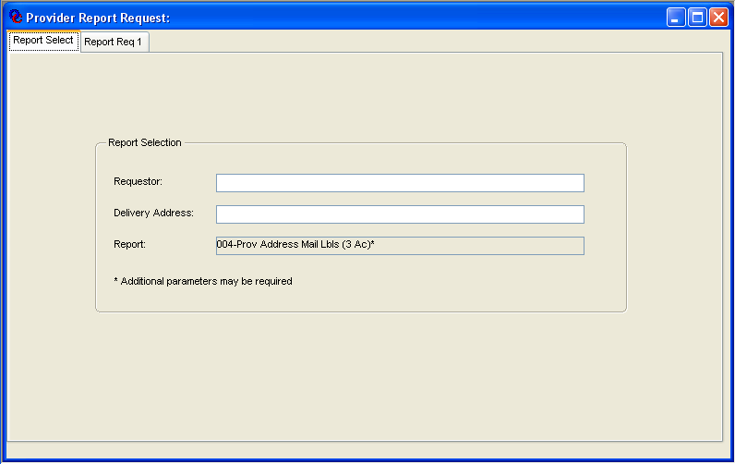
NEW MEXICO OMNICAID MMIS PROVIDER SUBSYSTEM
WINDOW EXHIBIT
PROVIDER REPORT REQUEST FUNCTIONAL GROUP
PROVIDER REPORT REQUEST TAB PAGE

Field Name | Table  Column Name | Table Name | Format | Prot  (A,C,N) | Req  (A,C,N) | Std Edits | Specifications | Note  Ref
Requester | P_REQUESTOR_NAM | P_RPT_REQ_TB | X(30) | N | A | N/A
Delivery Address | P_DELIVERY_AD | P_RPT_REQ_TB | X(30) | N | A | N/A
Report | N/A | N/A | X(30) | N | N/A | V | Contains the report code long description from the valid value table 356.

_________________________________________________________________________________________________________________________________

LEGEND: For Prot and Req: A = Always For Std Edits: D = Date Edit V = Valid Value Edit
C = Conditionally N = Numeric Edits S = System Generated
N = Never

NEW MEXICO OMNICAID MMIS PROVIDER SUBSYSTEM
WINDOW SPECIFICATION
PROVIDER REPORT REQUEST FUNCTIONAL GROUP
REPORT REQUEST 1 TAB PAGE

Window Name: W_PROV_RPT_REQ_1
Description:
The Report Request 1 Tab Page allows the requester to enter a specific Provider ID or choose selection criteria for the report selected on the Provider Report Request Window. (Either Mailing Labels of Information Sheet.) If mailing labels are requested, the user can specify the number of sets of mailing labels.

If the report is for a specific provider, the user enters the Provider ID in the Provider group Box. If the provider selected is a Managed Care Organization or a group such as group practice, billing agent or association, the user will click on “Include Group Members” if hey want a report for each group member as well as the group itself. When tabbing out of the Provider group box, the selection information that is no longer applicable has been removed from the window. Also, if “Include Group Members” is not checked, the Report Request 2 tab will be disabled because the sort selection will not be needed.

The address type and sets of mailing labels only appear on the window if the report selected is “Mailing Labels”.

Presentation Sequence(s):
N/A

Special Security Requirements:
N/A

Remarks:
If Provider ID is entered, Billing, Enrollment Status, Provider Type, County, Specialty, and Major Program may not be selected.

NEW MEXICO OMNICAID MMIS PROVIDER SUBSYSTEM
WINDOW LAYOUT
PROVIDER REPORT REQUEST FUNCTIONAL GROUP
REPORT REQUEST 1 TAB PAGE
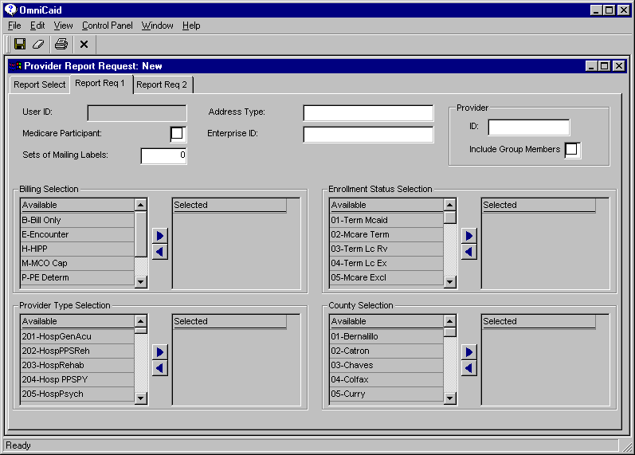

NEW MEXICO OMNICAID MMIS PROVIDER SUBSYSTEM
WINDOW EXHIBIT
PROVIDER REPORT REQUEST FUNCTIONAL GROUP
REPORT REQUEST 1 TAB PAGE

Field Name | Table  Column Name | Table Name | Format | Prot (A,C,N) | Req  (A,C,N) | Std Edits | Specifications | Note  Ref
User ID | G_AUD_USER_ID | P_RPT_REQ_TB | X(7) | A | N/A | N/A | Defaults to the User ID from the system after the user saves the request.
Address Type | P_ADR_TY_CD | P_RPT_REQ_TB | X(14) | C | N | V | Contains address type codes and their short descriptions from the valid value table 202. An address type can only be chosen for Mailing Labels. If a line is selected, the address type code is moved into the report request table.  Default is space.
Medicare Recipient | P_MCARE_IND | P_RPT_REQ__TB | X(1) | N | N | N/A | If this box is checked, a “Y” Will be moved to the table. If it is not checked, an “N” will be moved.
Enterprise ID | P_NTRPRS_ID | P_RPT_REQ_TB | X(8) | N | N | N | Default is space.
ID | P_ID | P_RPT_REQ_TB | X(8) | N | N | N/A | Default is space. | 1
Include Group Members | P_INCL_GRP_MEM_IND | P_RPT_REQ_TB | X(1) | N | N | N/A | Default is space. | 2
Sets of Mailing Labels | P_LABEL_SETS_NUM | P_RPT_REQ_TB | 9(4) | C | N | N | Can only be chosen for Mailing Labels. Default is 0.
Billing Codes | N/A | N/A | X(14) | A | N | V | Contains the billing media codes and their short description from valid value table 2661.
Selected | P_BLNG_CD | P_RPT_REQ_BLNG_TB | X(14) | A | N | V | The billing code from valid value table 2661 is inserted into the table.
Enrollment  Statuses | N/A | N/A | X(15) | A | N | V | Contains the enrollment statuses and their short description from valid value table 189.
Selected | P_ENROL_STAT_TY_CD | P_RPT_REQ_STAT_TB | X(15) | A | N | V | The enrollment status code from valid value table 189 is inserted into the table.
Provider Types | N/A | N/A | X(16) | A | N | V | Contains the provider types and their short description From valid value table 204.
Selected | P_TY_CD | P_RPT_REQ_TY_TB | X(16) | A | N | V | The provider type code from valid value table 204 is inserted into the table.
Counties | N/A | N/A | X(15) | A | N | V | Contains the counties and their short description from valid value table 2639.
Selected | P_CNTY_CD | P_RPT_REQ_CNTY_TB | X(15) | A | N | N/A | The county code from valid value 2639 is inserted into the table.

Notes:

- If Provider ID is entered, Billing, Enrollment Status, Provider Type, County, Specialty, and Major Program may not be selected.
- If the Provider ID represents an MCO or a group, billing agent or association having affiliated, the user can choose if they want reports to be produced for members.
_______________________________________________________________________________________________________________________________

LEGEND: For Prot and Req: A = Always For Std Edits: D = Date Edit V = Valid Value Edit
C = Conditionally N = Numeric Edits S = System Generated
N = Never

NEW MEXICO OMNICAID MMIS PROVIDER SUBSYSTEM
WINDOW SPECIFICATION
PROVIDER REPORT REQUEST FUNCTIONAL GROUP
REPORT REQUEST 2 TAB PAGE

Window Name: W_PROV_RPT_REQ_2
Description:
The Report Selection 2 Tab Page allows the user to enter additional report selection criteria including specialties, major programs and sorts.
The list of sort fields is: Provider Number, Provider Sort Name, Provider Type, Zip Code, and County Code. From 1 to 5 sorts may be chosen in any order. The default sort sequence is provider number.

Presentation Sequence(s):
N/A

Special Security Requirements:
N/A

Remarks:
If a report is selected for providers in a specific county, a provider that has a mailing, billing OR location address in that county will be chosen.

NEW MEXICO OMNICAID MMIS PROVIDER SUBSYSTEM
WINDOW EXHIBIT
PROVIDER REPORT REQUEST FUNCTIONAL GROUP
REPORT REQUEST 2 TAB PAGE

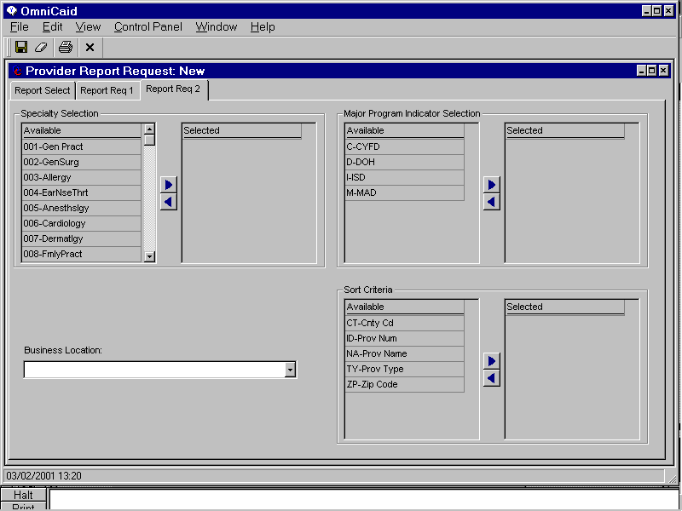

NEW MEXICO OMNICAID MMIS PROVIDER SUBSYSTEM
WINDOW EXHIBIT
PROVIDER REPORT REQUEST FUNCTIONAL GROUP
REPORT REQUEST 2 TAB PAGE

Field Name | Table  Column Name | Table Name | Format | Prot (A,C,N) | Req  (A,C,N) | Std Edits | Specifications | Note  Ref
Report Name | P_RPT_REQ_CD | P_RPT_REQ_TB | X(30) | A | N/A | N/A | The long description of the report name from valid value table 356 is displayed.
Specialties | N/A | N/A | X(16) | A | N | V | Contains the specialty codes short description from valid value table 2653.
Selected | P_SPECL_CD | P_RPT_REQ_SPECL_TB | X(16) | A | N | N/A | The specialty code from valid value table 2653 is inserted into the table.
Major Programs | N/A | N/A | X(14) | A | N | V | Contains the major program codes and their short description from valid value table 1620.
Selected | P_PROG_CD | P_RPT_REQ_PROG_TB | X(14) | A | N | N/A | The program code from valid value table 1620 is inserted into the table.
Business Location | P_LOCN_CD | P_RPT_REQ_TB | X(14) | N | N | V | Contains the location codes and their short description from valid value table 190. The location code is moved to the table. Default is space.
Sorted By | P_SORT_CD | P_RPT_REQ_SORT_TB | X(15) | A | N/A | N/A
Sort Fields | N/A | N/A | X(14) | A | N | V | Contains the sort field and their short description from valid value table 3418.

LEGEND: For Prot and Req: A = Always For Std Edits: D = Date Edit V = Valid Value Edit
C = Conditionally N = Numeric Edits S = System Generated
N = Never

3.2.3 Medicare Carrier Functional Group

This functional group captures Medicare Carrier information.

There are no GOTO navigation capabilities for the functional group.

The following windows are used by the Medicare Carrier functional group:

- Provider Medicare Carrier Selection
- Provider Medicare Carrier Detail
- Medicare Part D Provider Detail

NEW MEXICO OMNICAID MMIS PROVIDER SUBSYSTEM
WINDOW SPECIFICATION
PROVIDER MEDICARE CARRIER FUNCTIONAL GROUP
PROVIDER MEDICARE CARRIER SELECTION WINDOW

Window Name: W_PROV_MEDICARE_CARRIER
Description:
The Provider Medicare Carrier Selection Window is used to search the database for carriers that have already been entered or to create a new carrier. He user can search for an existing carrier by Carrier ID or Carrier Name. The carrier can then be selected and the Medicare Carrier Detail screen will be displayed. Here the user can change or delete the carrier.
To request a new carrier, the user presses the New button at the bottom of the window. The Medicare Carrier Detail Window will be displayed enabling the user to enter carrier information.

Presentation Sequence:
Carrier Name

Special Security Requirements:
N/A

Remarks:
N/A

NEW MEXICO OMNICAID MMIS PROVIDER SUBSYSTEM
WINDOW LAYOUT
PROVIDER MEDICARE CARRIER FUNCTIONAL GROUP
PROVIDER MEDICARE CARRIER SELECTION WINDOW

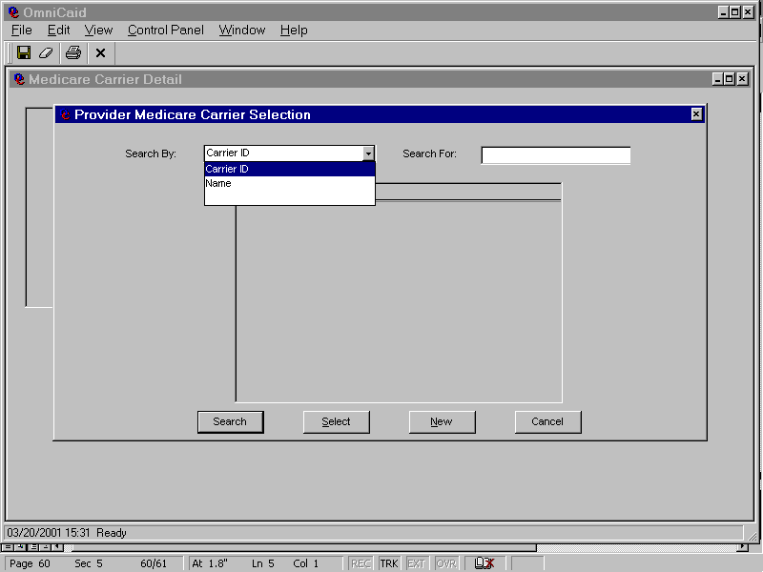

NEW MEXICO OMNICAID MMIS PROVIDER SUBSYSTEM
WINDOW EXHIBIT
PROVIDER MEDICARE CARRIER FUNCTIONAL GROUP
PROVIDER MEDICARE CARRIER SELECTION WINDOW

Field Name | Table  Column Name | Table Name | Format | Prot  (A,C,N) | Req  (A,C,N) | Std Edits | Specifications | Note  Ref
Search By | N/A | N/A | X(8) | N | A | N/A | User chooses Carrier ID or Name from a drop-down.
Search For | N/A | N/A | N/A | N | A | N/A | User types in a full or partial Carrier ID or a full or partial Name.
Carrier ID | P_MC_CARR_ID | P_MCARE_CARR_TB | X(10) | A | N/A | N/A
Carrier Name | P_MC_CARR_NAM | P_MCARE_CARR_TB | X(50) | A | N/A | N/A

_______________________________________________________________________________________________________________________________

LEGEND: For Prot and Req: A = Always For Std Edits: D = Date Edit V = Valid Value Edit
C = Conditionally N = Numeric Edits S = System Generated
N = Never

NEW MEXICO OMNICAID MMIS PROVIDER SUBSYSTEM
WINDOW SPECIFICATION
PROVIDER MEDICARE CARRIER FUNCTIONAL GROUP
MEDICARE CARRIER DETAIL

Window Name: W_MC_CARR_DTL
Description:
The Medicare Carrier Detail window allows the user to add, update or delete the carrier name, address and phone number.

Presentation Sequence(s):
N/A

Special Security Requirements:
N/A

Remarks:

NEW MEXICO OMNICAID MMIS PROVIDER SUBSYSTEM
WINDOW LAYOUT
PROVIDER MEDICARE CARRIER FUNCTIONAL GROUP
MEDICATE CARRIER DETAIL

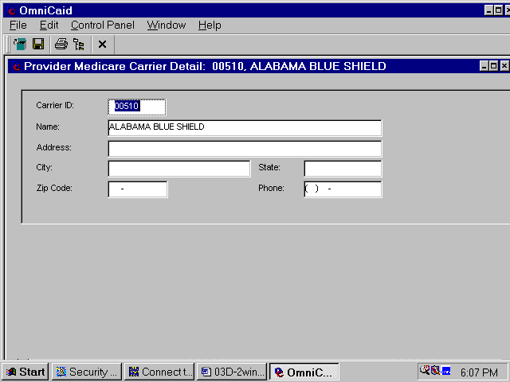

NEW MEXICO OMNICAID MMIS PROVIDER SUBSYSTEM
WINDOW EXHIBIT
PROVIDER MEDICARE CARRIER FUNCTIONAL GROUP
MEDICARE CARRIER DETAIL

Field Name | Table  Column Name | Table Name | Format | Prot (A,C,N) | Req  (A,C,N) | Std Edits | Specifications | Note  Ref
Carrier ID | P_MC_CARR_ID | P_MCARE_CARR_TB | X(10) | N | A | N/A
Carrier Name | P_MC_CARR_NAM | P_MCARE_CARR_TB | X(50) | N | A | N/A
Address | P_MC_CARR_AD | P_MCARE_CARR_TB | X(50) | N | N | N/A | Default is space.
City | P_MCARE_CARR_TB | P_MCARE_CARR_TB | X(20) | N | N | N/A | Default is space.
State | P_MC_CARR_ST_CD | P_MCARE_CARR_TB | X(2) | N | N | V | Default is space. Drop-down contains P_MC_CARR_ST_CD P_MC_CARR_TB and its short description from the valid value table 2638.
Zip Code | P_MC_CARR_ZIP_CD | P_MCARE_CARR_TB | X(9) | N | N | N/A | Default is space.
Phone | P_MC_CARR_PHON_NUM | P_MCARE_CARR_TB | X(10) | N | N | N/A | Default is space.

_______________________________________________________________________________________________________________________________

LEGEND: For Prot and Req: A = Always For Std Edits: D = Date Edit V = Valid Value Edit
C = Conditionally N = Numeric Edits S = System Generated
N = Never
NEW MEXICO OMNICAID MMIS PROVIDER SUBSYSTEM
WINDOW SPECIFICATION
PROVIDER MEDICARE CARRIER FUNCTIONAL GROUP
PROVIDER MEDICARE PART D CARRIER SELECTION WINDOW

Window Name: W_PROV_PARTD_SEARCH
Description:
The Provider Medicare Part D Carrier Selection Window is used to search the database for Part D carriers that have already been entered or to create a new carrier. The user can search for an existing carrier by Contract ID, Plan ID, State, or Organization Name. The carrier can then be selected and the Medicare Part D Carrier Detail screen will be displayed.

To request a new carrier, the user presses the New button at the bottom of the window. The Medicare Part D Carrier Detail Window will be displayed enabling the user to enter carrier information.

Presentation Sequence:
Organization Name, Contract ID, Plan ID

Special Security Requirements:
N/A

Remarks:
N/A

NEW MEXICO OMNICAID MMIS PROVIDER SUBSYSTEM
WINDOW LAYOUT

PROVIDER MEDICARE CARRIER FUNCTIONAL GROUP
PROVIDER MEDICARE PART D CARRIER SELECTION WINDOW

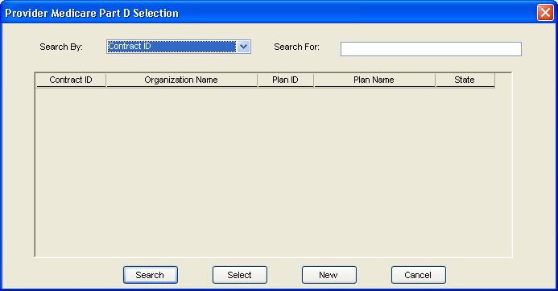

NEW MEXICO OMNICAID MMIS PROVIDER SUBSYSTEM
WINDOW EXHIBIT
PROVIDER MEDICARE CARRIER FUNCTIONAL GROUP
PROVIDER MEDICARE PART D CARRIER SELECTION WINDOW

Field Name | Table  Column Name | Table Name | Format | Prot  (A,C,N) | Req  (A,C,N) | Std Edits | Specifications | Note  Ref
Search By | N/A | N/A | X(8) | N | A | N/A | User chooses Contract ID or Name, or Plan ID or Plan Name from a drop-down.
Search For | N/A | N/A | N/A | N | A | N/A | User types in a full or partial Contract ID, Organization Name, Plan ID, or Plan Name .
Contract ID | B-PBP-CNTRCT-ID | P_MCARE_PARTD_TB | X(05) | A | N/A | N/A
Organization Name | P_PBP_ORG_NAM | P_MCARE_PARTD_TB | X(30) | A | N/A | N/A
Plan ID | B-PBP-PLN-ID | P_MCARE_PARTD_TB | X(03) | A | N/A | N/A
Plan Name | P_PBP_PLN_NAM | P_MCARE_PARTD_TB | X(30) | A | N/A | N/A
State | P_PBP_ST_CD | P_MCARE_PARTD_TB | X(02) | A | N/A | N/A

_______________________________________________________________________________________________________________________________

LEGEND: For Prot and Req: A = Always For Std Edits: D = Date Edit V = Valid Value Edit
C = Conditionally N = Numeric Edits S = System Generated
N = Never
NEW MEXICO OMNICAID MMIS PROVIDER SUBSYSTEM
WINDOW SPECIFICATION
PROVIDER MEDICARE CARRIER FUNCTIONAL GROUP
MEDICARE PART D CARRIER DETAIL

Window Name: W_PROV_PARTD_DTL
Description:
The Medicare Part D Carrier Detail window allows the user to add, update or delete the Part D Carrier and Contract details.

Presentation Sequence(s):
N/A

Special Security Requirements:
N/A

Remarks:

NEW MEXICO OMNICAID MMIS PROVIDER SUBSYSTEM
WINDOW LAYOUT
PROVIDER MEDICARE CARRIER FUNCTIONAL GROUP
MEDICARE PART D CARRIER DETAIL

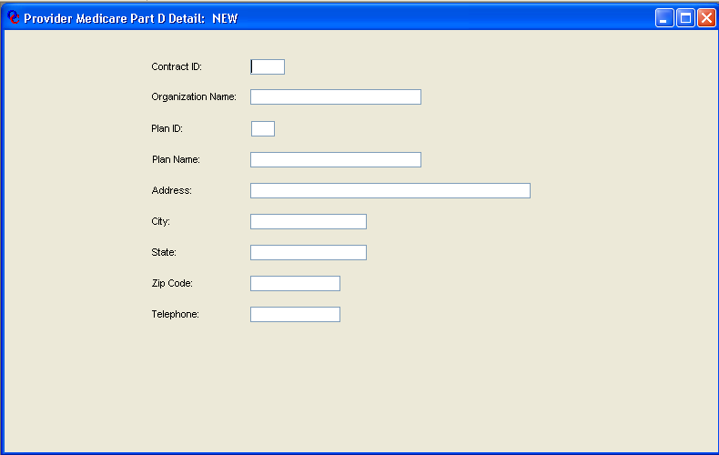
NEW MEXICO OMNICAID MMIS PROVIDER SUBSYSTEM
WINDOW EXHIBIT
PROVIDER MEDICARE CARRIER FUNCTIONAL GROUP
MEDICARE PART D CARRIER DETAIL

Field Name | Table  Column Name | Table Name | Format | Prot (A,C,N) | Req  (A,C,N) | Std Edits | Specifications | Note  Ref
Contract ID | B-PBP-CNTRCT-ID | P_MCARE_PARTD_TB | X(05) | A | A | N/A | For new rows, Contract ID and Plan ID combination may not already exist on the table.
Organization Name | P_PBP_ORG_NAM | P_MCARE_PARTD_TB | X(30) | N | A | N/A
Plan ID | B-PBP-PLN-ID | P_MCARE_PARTD_TB | X(03) | A | A | N/A | For new rows, Contract ID and Plan ID combination may not already exist on the table.
Plan Name | P_PBP_PLN_NAM | P_MCARE_PARTD_TB | X(30) | N | A | N/A
Address | P_PBP_ADR | P_MCARE_PARTD_TB | X(50) | N | N | N/A | Default is space.
City | P_PBP_CITY | P_MCARE_PARTD_TB | X(20) | N | N | N/A | Default is space.
State | P_PBP_ST_CD | P_MCARE_PARTD_TB | X(2) | N | N | V | Default is space. Drop-down contains P_PBP_ST_CD P_MCARE_PARTD_TB and its short description from the valid value table 2638.
Zip Code | P_PBP_ZIP_CD | P_MCARE_PARTD_TB | X(9) | N | N | N/A | Default is space.
Phone | P_PBP_PHON_NUM | P_MCARE_PARTD_TB | X(10) | N | N | N/A | Default is space.

_______________________________________________________________________________________________________________________________

LEGEND: For Prot and Req: A = Always For Std Edits: D = Date Edit V = Valid Value Edit
C = Conditionally N = Numeric Edits S = System Generated
N = Never

3.2.4 Provider Type/Specialty Cross Reference Functional Group

This functional group captures and displays Provider Type/Specialty Cross Reference information.

There are no GOTO navigation capabilities for the functional group.

The following windows are used by the Provider Type/Specialty Cross Reference functional group:

- Provider Type/Specialty Cross Reference

NEW MEXICO OMNICAID MMIS PROVIDER SUBSYSTEM
WINDOW SPECIFICATION
PROVIDER TYPE/SPECIALTY CROSS REFERENCE FUNCTIONAL GROUP
PROVIDER TYPE/SPECIALTY CROSS REFERENCE WINDOW

Window Name: W_PROV_TY_SPECL_X
Description:
The Provider Type/Specialty Cross Reference Window is used to search the database for Provider Specialties that have already been entered or to create a new type/specialty cross reference item. The user can search for an existing cross reference by Provider Type or Provider Specialty. The window displays all cross reference records that match the search criteria.

To enter a new cross reference, the user presses the ‘+’ button in the upper left corner of the type/specialty display of the window. To delete an existing row, the user highlights the row to be deleted and presses the ‘-‘ button.

Presentation Sequence:
Provider Type, Provider Specialty

Special Security Requirements:
This window should only be available for update to system support staff.

Remarks:
N/A

NEW MEXICO OMNICAID MMIS PROVIDER SUBSYSTEM
WINDOW SPECIFICATION
PROVIDER TYPE/SPECIALTY CROSS REFERENCE FUNCTIONAL GROUP
PROVIDER TYPE/SPECIALTY CROSS REFERENCE WINDOW
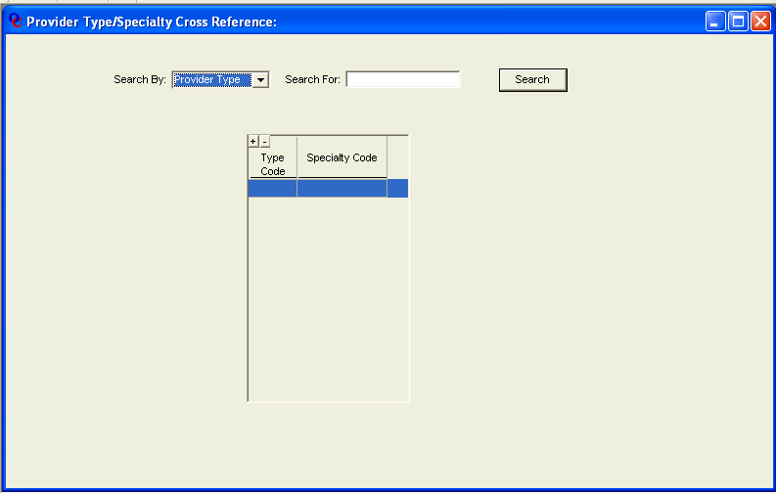

NEW MEXICO OMNICAID MMIS PROVIDER SUBSYSTEM
WINDOW EXHIBIT
PROVIDER TYPE/SPECIALTY CROSS REFERENCE FUNCTIONAL GROUP
PROVIDER TYPE/SPECIALTY CROSS REFERENCE WINDOW

Field Name | Table  Column Name | Table Name | Format | Prot (A,C,N) | Req  (A,C,N) | Std Edits | Specifications | Note  Ref
Search By | N/A | N/A | X(02) | N | A | N/A | User may choose to search by Provider Type or Provider Specialty
Search For | N/A | N/A | N/A | N | A | N/A | User enters criteria specific to the Search By value chosen.
Type Code | P_TY_CD | P_TY_SPECL_X_TB | X(03) | A | N/A | N/A
Specialty Code | P_SPECL_CD | P_TY_SPECL_X_TB | X(03) | A | N/A | N/A

_______________________________________________________________________________________________________________________________

LEGEND: For Prot and Req: A = Always For Std Edits: D = Date Edit V = Valid Value Edit
C = Conditionally N = Numeric Edits S = System Generated
N = Never

3.2.5 Provider Taxonomy Cross Match Functional Group

This functional group captures and displays Provider Taxonomy Cross Match information.

There are no GOTO navigation capabilities for the functional group.

The following windows are used by the Provider Taxonomy Cross Match functional group:

- Provider Taxonomy Cross Match

NEW MEXICO OMNICAID MMIS PROVIDER SUBSYSTEM
WINDOW SPECIFICATION
PROVIDER TAXONOMY CROSS MATCH FUNCTIONAL GROUP
PROVIDER TAXONOMY CROSS MATCH WINDOW

Window Name:
Description:
The Provider Taxonomy Cross Match Window is used to search the database for Provider Taxonomies that have already been entered or to create a new Provider Type to Taxonomy cross match item. The user can search for an existing cross match by Provider Type or Provider Taxonomy. The window displays all cross match records that match the search criteria.

To enter a new cross match item, the user presses the ‘+’ button in the upper left corner of the type/Taxonomy display of the window. To delete an existing row, the user highlights the row to be deleted and presses the ‘-‘ button.

Presentation Sequence:
Provider Type, Provider Taxonomy

Special Security Requirements:
This window should only be available for update to system support staff.

Remarks:
N/A

NEW MEXICO OMNICAID MMIS PROVIDER SUBSYSTEM
WINDOW SPECIFICATION
PROVIDER TAXONOMY CROSS MATCH FUNCTIONAL GROUP
PROVIDER TAXONOMY CROSS MATCH WINDOW

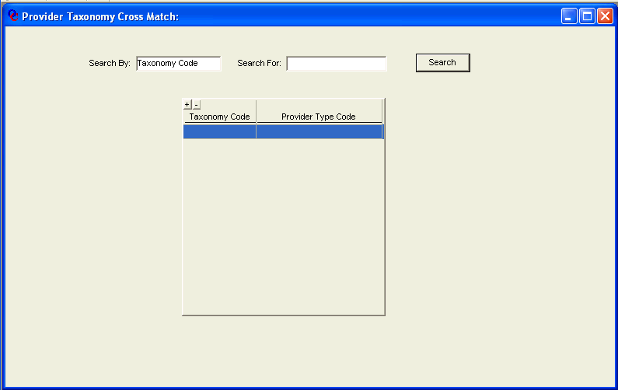

NEW MEXICO OMNICAID MMIS PROVIDER SUBSYSTEM
WINDOW EXHIBIT
PROVIDER TAXONOMY CROSS MATCH FUNCTIONAL GROUP
PROVIDER TAXONOMY CROSS MATCH WINDOW

Field Name | Table  Column Name | Table Name | Format | Prot (A,C,N) | Req  (A,C,N) | Std Edits | Specifications | Note  Ref
Search By | N/A | N/A | X(02) | N | A | N/A | User may choose to search by Provider Type or Taxonomy Code
Search For | N/A | N/A | N/A | N | A | N/A | User enters criteria specific to the Search By value chosen.
Taxonomy Code | P_TXNMY_CD | P_TXNMY_XMTCH_TB | X(10) | A | N/A | N/A
Provider Type | P_TY_CD | P_TXNMY_XMTCH_TB | X(03) | A | N/A | N/A

_______________________________________________________________________________________________________________________________

LEGEND: For Prot and Req: A = Always For Std Edits: D = Date Edit V = Valid Value Edit
C = Conditionally N = Numeric Edits S = System Generated
N = Never

3.2.6 Provider EFT Administration Functional Group

This functional group captures and displays the information that is required in order to process electronic fund transfers to a provider.

The following table presents the GOTO navigation capabilities for the functional group. For each GOTO option in the functional group, the following information is identified: the subsystem and functional group navigated to when the GOTO option is selected, the window field used as the key field for the GOTO functional group, and the window name where the key field resides (if appropriate).

GOTO Subsystem | GOTO Functional Group | Window Field | Window
Provider | Provider Detail | Provider ID | N/A

The following windows are used by the Provider EFT Administration functional group:

- Provider EFT Administration Selection
- Provider EFT Administration

NEW MEXICO OMNICAID MMIS PROVIDER SUBSYSTEM
WINDOW SPECIFICATION
PROVIDER EFT ADMINISTRATION FUNCTIONAL GROUP
PROVIDER EFT ADMINISTRATION SELECTION WINDOW

Window Name: W_PROV_EFT_SEARCH
Description: The Provider EFT Administration Selection Window is used to search the database for Active Providers (with enrollment status of 60 or 70). The user can search for an existing, active Provider by Provider ID, NPI, Provider Name. The Provider can then be selected and the EFT Administration window will be displayed.

EFT Account information may be updated or displayed only on currently active Providers with an enrollment status of ‘60’ or ‘70’. Since a provider must already exist, the ‘NEW’ command button on the selection window is disabled.

Presentation Sequence:

Provider Sort Name, ascending and Provider ID, ascending
Special Security Requirements:

The EFT Administration windows will be contains in separate security groups. Once for Inquiry Only access and one for Update access. Only those individuals assigned one of these two security groups will have access to the EFT Administration functional group.

Remarks:
N/A

NEW MEXICO OMNICAID MMIS PROVIDER SUBSYSTEM
WINDOW SPECIFICATION
PROVIDER EFT ADMINISTRATION FUNCTIONAL GROUP
PROVIDER EFT ADMINISTRATION SELECTION WINDOW

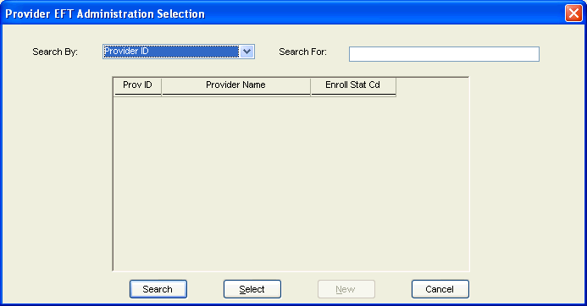

NEW MEXICO OMNICAID MMIS PROVIDER SUBSYSTEM
WINDOW EXHIBIT
PROVIDER EFT ADMINISTRATION FUNCTIONAL GROUP
PROVIDER EFT ADMINISTRATION SELECTION WINDOW

Field Name | Table  Column Name | Table Name | Format | Prot (A,C,N) | Req  (A,C,N) | Std Edits | Specifications | Note  Ref
Search By | N/A | N/A | X(02) | N | A | N/A | User may choose to search by Provider ID, Provider Name, or by NPI
Search For | N/A | N/A | N/A | N | A | N/A | User enters criteria specific to the Search For value chosen.
Prov ID | P_ID | P_PROV_TB | X(08) | A | N/A | N/A
Provider Name | P_SORT_NAM | P_PROV_TB | X(35) | A | N/A | N/A
Enroll Stat Cd | P_ENROL_STAT_TY_CD | P_ENROL_STAT_TB | X(02) | A | N/A | N/A

_______________________________________________________________________________________________________________________________

LEGEND: For Prot and Req: A = Always For Std Edits: D = Date Edit V = Valid Value Edit
C = Conditionally N = Numeric Edits S = System Generated
N = Never
NEW MEXICO OMNICAID MMIS PROVIDER SUBSYSTEM
WINDOW SPECIFICATION
PROVIDER EFT ADMINISTRATION FUNCTIONAL GROUP
PROVIDER EFT ADMINISTRATION WINDOW

Window Name: W_PROV_EFT_ACCT
Description:

Presentation Sequence:

Special Security Requirements:

Remarks:
N/A

NEW MEXICO OMNICAID MMIS PROVIDER SUBSYSTEM
WINDOW SPECIFICATION
PROVIDER EFT ADMINISTRATION FUNCTIONAL GROUP
PROVIDER EFT ADMINISTRATION WINDOW
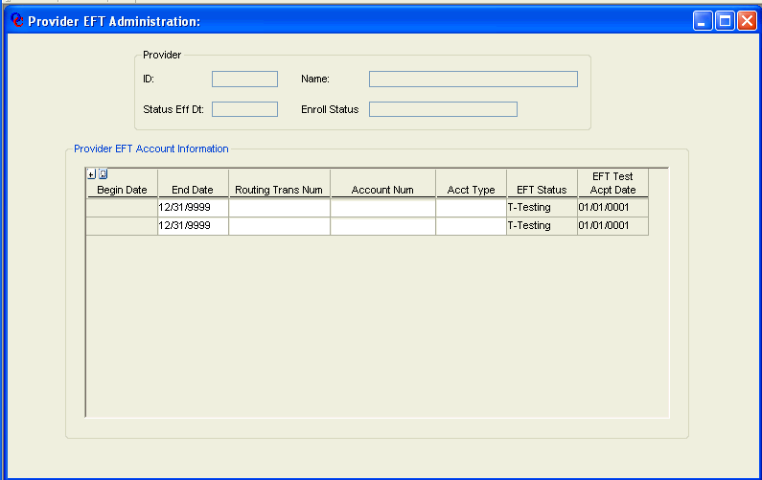

NEW MEXICO OMNICAID MMIS PROVIDER SUBSYSTEM
WINDOW EXHIBIT
PROVIDER EFT ADMINISTRATION FUNCTIONAL GROUP
PROVIDER EFT ADMINISTRATION WINDOW

Field Name | Table  Column Name | Table Name | Format | Prot (A,C,N) | Req  (A,C,N) | Std Edits | Specifications | Note  Ref
Provider | N/A | N/A | N/A | A | N/A | N/A | Groupbox
ID | P_ID | P_PROV_TB | X(08) | A | N/A | N/A
Status Eff Dt | P_STAT_EFF_DT | P_ENROL_STAT_TB | DATE | A | N/A | N/A
Name | P_NAM | P_PROV_TB | X(32) | A | N/A | N/A
Enroll Status | P_ENROL_STAT_TY_CD | P_ENROL_STAT_TB | X(02) | A | N/A | N/A
Provider EFT Account Information | N/A | N/A | N/A | A | N/A | N/A | Groupbox
Begin Date | P_EFT_BEG_DT | P_EFT_ACCT_TB | DATE | A | A | D | No retroactive dates allowed. No future dates allowed. System sets current date on new rows and protects the field from modification.
End Date | P_EFT_END_DT | P_EFT_ACCT_TB | DATE | C | A | D | Defaults to 12/31/9999
Routing Trans Num | P_ROUT_TRANS_NUM | P_EFT_ACCT_TB | 9(09) | C | A | S | Must satisfy validation algorithm
Account Num | P_ACCT_NUM | P_EFT_ACCT_TB | X(17) | C | A | N/A
Acct Type | P_ACCT_TY_CD | P_EFT_ACCT_TB | X(01) | C | A | V
EFT Status | P_EFT_STAT_CD | P_EFT_ACCT_TB | X(01) | A | A | V | System Generated, defaults to ‘T-TEST’
EFT Test Acpt Date | P_EFT_TEST_ACPT_DT | P_EFT_ACCT_TB | DATE | A | A | D | System Generated, defaults to 01/01/0001

_______________________________________________________________________________________________________________________________

LEGEND: For Prot and Req: A = Always For Std Edits: D = Date Edit V = Valid Value Edit
C = Conditionally N = Numeric Edits S = System Generated
N = Never

3.2.7 Provider Owner Detail Functional Group

This functional group captures and displays the provider owner information that is required in order to associate certain owners with certain providers.

The following windows are used by the Provider Owner Detail functional group:

- Provider Owner Selection
- Provider Owner Detail

NEW MEXICO OMNICAID MMIS PROVIDER SUBSYSTEM
WINDOW SPECIFICATION
PROVIDER OWNER DETAIL FUNCTIONAL GROUP
PROVIDER OWNER SELECTION WINDOW

Window Name: W_PROV_OWNER_SEARCH
Description: The Provider Owner Selection Window is used to search the database for Owners that can by associated to certain Providers. The user can search for an existing, Owner by Tax ID, Last Name or Legal Name. The Owner can then be selected and the Provider Owner Detail window will be displayed.

Presentation Sequence:

Tax ID Ascending

Special Security Requirements:

The Provider Owner Search window will be contained in separate security groups. One for Inquiry Only access and one for Update access. Only those individuals assigned one of these two security groups will have access to the Provider Owner Detail functional group.

Remarks:
N/A

NEW MEXICO OMNICAID MMIS PROVIDER SUBSYSTEM
WINDOW SPECIFICATION
PROVIDER OWNER DETAIL FUNCTIONAL GROUP
PROVIDER OWNER SELECTION WINDOW

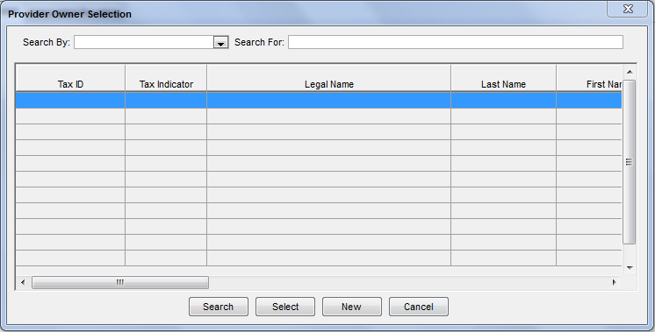
NEW MEXICO OMNICAID MMIS PROVIDER SUBSYSTEM
WINDOW SPECIFICATION
PROVIDER OWNER DETAIL FUNCTIONAL GROUP
PROVIDER OWNER SELECTION WINDOW

Field Name | Table  Column Name | Table Name | Format | Prot (A,C,N) | Req  (A,C,N) | Std Edits | Specifications | Note  Ref
Search By | N/A | N/A | X(02) | N | A | N/A | User may choose to search by Tax ID, Last Name or Legal Name
Search For | N/A | N/A | N/A | N | A | N/A | User enters criteria specific to the Search For value chosen.
Tax ID | P_OWNEMP_EINSSN_ID | P_OWNEMP_INFO_TB | X(9) | A | N | N/A | Format is ##-####### if Tax Indicator is Owner FEIN. Format is ###-##-#### if Tax Indicator is Owner SSN.
Tax Indicator | P_OWNEMP_TAX_IND | P_OWNEMP_INFO_TB | X(1) | A | N | V | Valid Values:  1: Owner FEIN  2: Owner SSN  3: Employee SSN
Legal Name | P_OWNEMP_DBA_NAM | P_OWNEMP_INFO_TB | X(45) | A | N | N/A
Last Name | P_OWNEMP_LAST_NAM | P_OWNEMP_INFO_TB | X(35) | A | N | N/A
First Name | P_OWNEMP_FST_NAM | P_OWNEMP_INFO_TB | X(15) | A | N | N/A
MI | P_OWNEMP_MI_NAM | P_OWNEMP_INFO_TB | X(1) | A | N | N/A
Suffix | P_OWNEMP_SFX_NAM | P_OWNEMP_INFO_TB | X(10) | A | N | N/A
Title | P_OWNEMP_TITL_NAM | P_OWNEMP_INFO_TB | X(10) | A | N | N/A
DOB | P_OWNEMP_DOB_DT | P_OWNEMP_INFO_TB | DATE | A | N | D | Format is MM/DD/YYYY
Address Line 1 | P_OWNEMP_LINE1_AD | P_OWNEMP_INFO_TB | X(45) | A | N | N/A
Address Line 2 | P_OWNEMP_LINE2_AD | P_OWNEMP_INFO_TB | X(45) | A | N | N/A
City | P_OWNEMP_CITY_NAM | P_OWNEMP_INFO_TB | X(20) | A | N | N/A
State | P_OWNEMP_ST_CD | P_OWNEMP_INFO_TB | X(2) | A | N | N/A
Zip | P_OWNEMP_ZIP5_CD | P_OWNEMP_INFO_TB | X(5) | A | N | N/A
 | P_OWNEMP_ZIP4_CD | P_OWNEMP_INFO_TB | X(4) | A | N | N/A
County | P_OWNEMP_CNTY_CD | P_OWNEMP_INFO_TB | X(2) | A | N | N/A
Country | P_OWNEMP_CNTRY_NAM | P_OWNEMP_INFO_TB | X(15) | A | N | N/A
Phone | P_OWNEMP_PHON_NUM | P_OWNEMP_INFO_TB | X(10) | A | N | N/A
Fax | P_OWNEMP_FAX_NUM | P_OWNEMP_INFO_TB | X(10) | A | N | N/A

_______________________________________________________________________________________________________________________________

LEGEND: For Prot and Req: A = Always For Std Edits: D = Date Edit V = Valid Value Edit
C = Conditionally N = Numeric Edits S = System Generated
N = Never
NEW MEXICO OMNICAID MMIS PROVIDER SUBSYSTEM
WINDOW SPECIFICATION
PROVIDER OWNER DETAIL FUNCTIONAL GROUP
DETAIL TAB PAGE

Window Name: W_PROV_OWNER_DTL/UO_TABPG_PROV_OWNER_ENTRY
Description:
The Provider Owner Detail Tab Page allows the ability to add new or update existing Owner information.

Special Security Requirements:
The Provider Owner Detail window will be contained in separate security groups. One for Inquiry Only access and one for Update access. Only those individuals assigned one of these two security groups will have access to the Provider Owner Detail functional group.

Presentation Sequence(s):
N/A

Remarks:
N/A

NEW MEXICO OMNICAID MMIS PROVIDER SUBSYSTEM
WINDOW SPECIFICATION
PROVIDER OWNER DETAIL FUNCTIONAL GROUP
DETAIL TAB PAGE

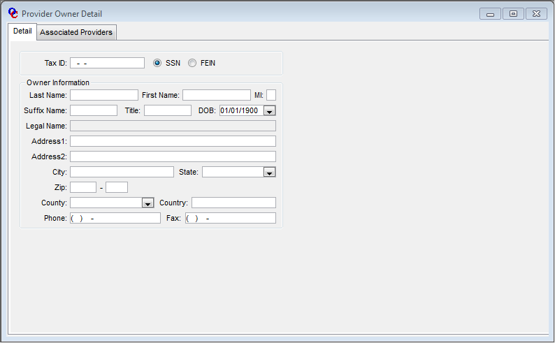
NEW MEXICO OMNICAID MMIS PROVIDER SUBSYSTEM
WINDOW SPECIFICATION
PROVIDER OWNER DETAIL FUNCTIONAL GROUP
DETAIL TAB PAGE

Field Name | Table  Column Name | Table Name | Format | Prot  (A,C,N) | Req  (A,C,N) | Std Edits | Specifications | Note  Ref
Tax ID | P_OWNEMP_EINSSN_ID | P_OWNEMP_INFO_TB | X(9) | N | A | N/A | Format is ##-####### if Tax Indicator is FEIN. Format is ###-##-#### if Tax Indicator is SSN.
Tax Indicator | P_OWNEMP_TAX_IND | P_OWNEMP_INFO_TB | X(1) | N | A | V | Valid Values:  1: Owner FEIN  2: Owner SSN  3: Employee SSN | 1
Last Name | P_OWNEMP_LAST_NAM | P_OWNEMP_INFO_TB | X(35) | A | N | N/A |  | 1
First Name | P_OWNEMP_FST_NAM | P_OWNEMP_INFO_TB | X(15) | A | N | N/A |  | 1
MI | P_OWNEMP_MI_NAM | P_OWNEMP_INFO_TB | X(1) | A | N | N/A |  | 1
Suffix | P_OWNEMP_SFX_NAM | P_OWNEMP_INFO_TB | X(10) | A | N | N/A |  | 1
Title | P_OWNEMP_TITL_NAM | P_OWNEMP_INFO_TB | X(10) | A | N | N/A |  | 1
DOB | P_OWNEMP_DOB_DT | P_OWNEMP_INFO_TB | DATE | A | N | D | Format is MM/DD/YYYY | 1
Legal Name | P_OWNEMP_DBA_NAM | P_OWNEMP_INFO_TB | X(45) | A | N | N/A |  | 1
Address Line 1 | P_OWNEMP_LINE1_AD | P_OWNEMP_INFO_TB | X(45) | A | N | N/A
Address Line 2 | P_OWNEMP_LINE2_AD | P_OWNEMP_INFO_TB | X(45) | A | N | N/A
City | P_OWNEMP_CITY_NAM | P_OWNEMP_INFO_TB | X(20) | A | N | N/A
State | P_OWNEMP_ST_CD | P_OWNEMP_INFO_TB | X(2) | A | N | N/A
Zip | P_OWNEMP_ZIP5_CD | P_OWNEMP_INFO_TB | X(5) | A | N | N/A
 | P_OWNEMP_ZIP4_CD | P_OWNEMP_INFO_TB | X(4) | A | N | N/A
County | P_OWNEMP_CNTY_CD | P_OWNEMP_INFO_TB | X(2) | A | N | N/A
Country | P_OWNEMP_CNTRY_NAM | P_OWNEMP_INFO_TB | X(15) | A | N | N/A
Phone | P_OWNEMP_PHON_NUM | P_OWNEMP_INFO_TB | X(10) | A | N | N/A | Format is (###) ###-####
Fax | P_OWNEMP_FAX_NUM | P_OWNEMP_INFO_TB | X(10) | A | N | N/A | Format is (###) ###-####

_______________________________________________________________________________________________________________________________

LEGEND: For Prot and Req: A = Always For Std Edits: D = Date Edit V = Valid Value Edit
C = Conditionally N = Numeric Edits S = System Generated
N = Never
Notes:
- If Tax Indicator is SSN then Legal Name field is not editable and the Last Name, First Name, MI, Suffix, Title, and DOB fields are editable. If the Tax Indicator is FEIN then the Legal Name field is editable and the Last Name, First Name, MI, Suffix, Title, and DOB fields are not editable.
NEW MEXICO OMNICAID MMIS PROVIDER SUBSYSTEM
WINDOW SPECIFICATION
PROVIDER OWNER DETAIL FUNCTIONAL GROUP
ASSOCIATED PROVIDERS TAB PAGE

Window Name: W_PROV_OWNER_DTL/UO_TABPG_PROV_OWNER_ASSOC
Description:
The Provider Owner Associated Providers Tab Page displays all Providers that are currently associated with the Owner.

Special Security Requirements:
N/A

Presentation Sequence(s):
N/A

Remarks:
N/A

NEW MEXICO OMNICAID MMIS PROVIDER SUBSYSTEM
WINDOW SPECIFICATION
PROVIDER OWNER DETAIL FUNCTIONAL GROUP
ASSOCIATED PROVIDERS TAB PAGE

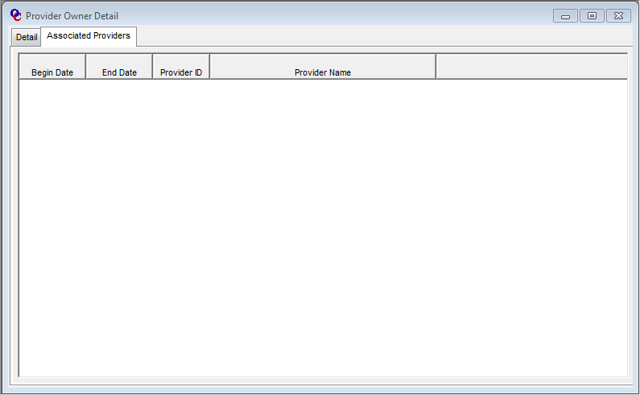
NEW MEXICO OMNICAID MMIS PROVIDER SUBSYSTEM
WINDOW SPECIFICATION
PROVIDER OWNER DETAIL FUNCTIONAL GROUP
ASSOCIATED PROVIDERS TAB PAGE

Field Name | Table  Column Name | Table Name | Format | Prot  (A,C,N) | Req  (A,C,N) | Std Edits | Specifications | Note  Ref
Begin Date | P_OWNEMP_BEG_DT | P_OWNEMP_XREF_TB | DATE | A | N | N/A | Format is MM/DD/YYYY
End Date | P_OWNEMP_END_DT | P_OWNEMP_XREF_TB | DATE | A | N | N/A | Format is MM/DD/YYYY
Provider ID | P_ID | P_OWNEMP_XREF_TB | X(08) | A | N | N/A
Provider Name | P_NAM | P_PROV_TB | X(45) | A | N | N/A
 | P_SORT_NAM | P_PROV_TB | X(45) | A | N | N/A

_______________________________________________________________________________________________________________________________

LEGEND: For Prot and Req: A = Always For Std Edits: D = Date Edit V = Valid Value Edit
C = Conditionally N = Numeric Edits S = System Generated
N = Never

3.2.8 Provider Manager/Employee Detail Functional Group

This functional group captures and displays the provider manager/employee information that is required in order to associate certain managers/employees with certain providers.

The following windows are used by the Provider Manager/Employee Detail functional group:

- Provider Manager/Employee Selection
- Provider Manager/Employee Detail

NEW MEXICO OMNICAID MMIS PROVIDER SUBSYSTEM
WINDOW SPECIFICATION
PROVIDER MANAGER/EMPLOYEE DETAIL FUNCTIONAL GROUP
PROVIDER MANAGER/EMPLOYEE SELECTION WINDOW

Window Name: W_PROV_MGREMP_SEARCH
Description: The Provider Manager/Employee Selection Window is used to search the database for Managers or Employees that can by associated to certain Providers. The user can search for an existing, Manager or Employee by SSN or Last Name. The Manager or Employee can then be selected and the Provider Manager/Detail Detail window will be displayed.

Presentation Sequence:

SSN Ascending

Special Security Requirements:

The Provider Manager/Employee Search window will be contained in separate security groups. One for Inquiry Only access and one for Update access. Only those individuals assigned one of these two security groups will have access to the Provider Manager/Employee Detail functional group.

Remarks:
N/A

NEW MEXICO OMNICAID MMIS PROVIDER SUBSYSTEM
WINDOW SPECIFICATION
PROVIDER MANAGER/EMPLOYEE DETAIL FUNCTIONAL GROUP
PROVIDER MANAGER/EMPLOYEE SELECTION WINDOW

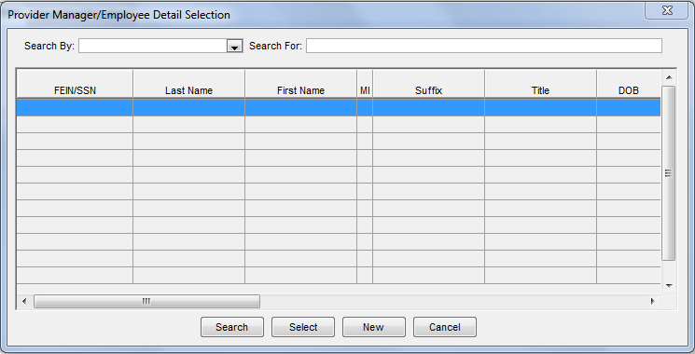
NEW MEXICO OMNICAID MMIS PROVIDER SUBSYSTEM
WINDOW SPECIFICATION
PROVIDER MANAGER/EMPLOYEE DETAIL FUNCTIONAL GROUP
PROVIDER MANAGER/EMPLOYEE SELECTION WINDOW

Field Name | Table  Column Name | Table Name | Format | Prot (A,C,N) | Req  (A,C,N) | Std Edits | Specifications | Note  Ref
Search By | N/A | N/A | X(02) | N | A | N/A | User may choose to search by SSN or Last Name
Search For | N/A | N/A | N/A | N | A | N/A | User enters criteria specific to the Search For value chosen.
SSN | P_OWNEMP_EINSSN_ID | P_OWNEMP_INFO_TB | X(9) | A | N | N/A | Format is ###-##-####
Last Name | P_OWNEMP_LAST_NAM | P_OWNEMP_INFO_TB | X(35) | A | N | N/A
First Name | P_OWNEMP_FST_NAM | P_OWNEMP_INFO_TB | X(15) | A | N | N/A
MI | P_OWNEMP_MI_NAM | P_OWNEMP_INFO_TB | X(1) | A | N | N/A
Suffix | P_OWNEMP_SFX_NAM | P_OWNEMP_INFO_TB | X(10) | A | N | N/A
Title | P_OWNEMP_TITL_NAM | P_OWNEMP_INFO_TB | X(10) | A | N | N/A
DOB | P_OWNEMP_DOB_DT | P_OWNEMP_INFO_TB | DATE | A | N | D | Format is MM/DD/YYYY
Address Line 1 | P_OWNEMP_LINE1_AD | P_OWNEMP_INFO_TB | X(45) | A | N | N/A
Address Line 2 | P_OWNEMP_LINE2_AD | P_OWNEMP_INFO_TB | X(45) | A | N | N/A
City | P_OWNEMP_CITY_NAM | P_OWNEMP_INFO_TB | X(20) | A | N | N/A
State | P_OWNEMP_ST_CD | P_OWNEMP_INFO_TB | X(2) | A | N | N/A
Zip | P_OWNEMP_ZIP5_CD | P_OWNEMP_INFO_TB | X(5) | A | N | N/A
 | P_OWNEMP_ZIP4_CD | P_OWNEMP_INFO_TB | X(4) | A | N | N/A
County | P_OWNEMP_CNTY_CD | P_OWNEMP_INFO_TB | X(2) | A | N | N/A
Country | P_OWNEMP_CNTRY_NAM | P_OWNEMP_INFO_TB | X(15) | A | N | N/A
Phone | P_OWNEMP_PHON_NUM | P_OWNEMP_INFO_TB | X(10) | A | N | N/A
Fax | P_OWNEMP_FAX_NUM | P_OWNEMP_INFO_TB | X(10) | A | N | N/A

_______________________________________________________________________________________________________________________________

LEGEND: For Prot and Req: A = Always For Std Edits: D = Date Edit V = Valid Value Edit
C = Conditionally N = Numeric Edits S = System Generated
N = Never
NEW MEXICO OMNICAID MMIS PROVIDER SUBSYSTEM
WINDOW SPECIFICATION
PROVIDER MANAGER/EMPLOYEE DETAIL FUNCTIONAL GROUP
DETAIL TAB PAGE

Window Name: W_PROV_MGREMP_DTL/UO_TABPG_PROV_MGREMP_ENTRY
Description:
The Provider Manager/Employee Detail Tab Page allows the ability to add new or update existing Manager or Employee information.

Special Security Requirements:
The Provider Manager/Employee Detail window will be contained in separate security groups. One for Inquiry Only access and one for Update access. Only those individuals assigned one of these two security groups will have access to the Provider Manager/Employee Detail functional group.

Presentation Sequence(s):
N/A

Remarks:
N/A

NEW MEXICO OMNICAID MMIS PROVIDER SUBSYSTEM
WINDOW SPECIFICATION
PROVIDER MANAGER/EMPLOYEE DETAIL FUNCTIONAL GROUP
DETAIL TAB PAGE

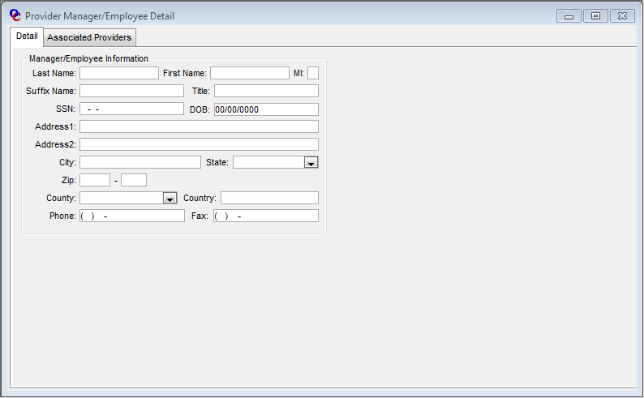
NEW MEXICO OMNICAID MMIS PROVIDER SUBSYSTEM
WINDOW SPECIFICATION
PROVIDER MANAGER/EMPLOYEE DETAIL FUNCTIONAL GROUP
DETAIL TAB PAGE

Field Name | Table  Column Name | Table Name | Format | Prot  (A,C,N) | Req  (A,C,N) | Std Edits | Specifications | Note  Ref
Last Name | P_OWNEMP_LAST_NAM | P_OWNEMP_INFO_TB | X(35) | A | N | N/A
First Name | P_OWNEMP_FST_NAM | P_OWNEMP_INFO_TB | X(15) | A | N | N/A
MI | P_OWNEMP_MI_NAM | P_OWNEMP_INFO_TB | X(1) | A | N | N/A
Suffix | P_OWNEMP_SFX_NAM | P_OWNEMP_INFO_TB | X(10) | A | N | N/A
Title | P_OWNEMP_TITL_NAM | P_OWNEMP_INFO_TB | X(10) | A | N | N/A
Tax ID | P_OWNEMP_EINSSN_ID | P_OWNEMP_INFO_TB | X(9) | N | A | N/A | Format is ###-##-####
DOB | P_OWNEMP_DOB_DT | P_OWNEMP_INFO_TB | DATE | A | N | D | Format is MM/DD/YYYY
Address Line 1 | P_OWNEMP_LINE1_AD | P_OWNEMP_INFO_TB | X(45) | A | N | N/A
Address Line 2 | P_OWNEMP_LINE2_AD | P_OWNEMP_INFO_TB | X(45) | A | N | N/A
City | P_OWNEMP_CITY_NAM | P_OWNEMP_INFO_TB | X(20) | A | N | N/A
State | P_OWNEMP_ST_CD | P_OWNEMP_INFO_TB | X(2) | A | N | N/A
Zip | P_OWNEMP_ZIP5_CD | P_OWNEMP_INFO_TB | X(5) | A | N | N/A
 | P_OWNEMP_ZIP4_CD | P_OWNEMP_INFO_TB | X(4) | A | N | N/A
County | P_OWNEMP_CNTY_CD | P_OWNEMP_INFO_TB | X(2) | A | N | N/A
Country | P_OWNEMP_CNTRY_NAM | P_OWNEMP_INFO_TB | X(15) | A | N | N/A
Phone | P_OWNEMP_PHON_NUM | P_OWNEMP_INFO_TB | X(10) | A | N | N/A | Format is (###) ###-####
Fax | P_OWNEMP_FAX_NUM | P_OWNEMP_INFO_TB | X(10) | A | N | N/A | Format is (###) ###-####

_______________________________________________________________________________________________________________________________

LEGEND: For Prot and Req: A = Always For Std Edits: D = Date Edit V = Valid Value Edit
C = Conditionally N = Numeric Edits S = System Generated
N = Never
NEW MEXICO OMNICAID MMIS PROVIDER SUBSYSTEM
WINDOW SPECIFICATION
PROVIDER MANAGER/EMPLOYEE DETAIL FUNCTIONAL GROUP
ASSOCIATED PROVIDERS TAB PAGE

Window Name: W_PROV_MGREMP_DTL/UO_TABPG_PROV_MGREMP_ASSOC
Description:
The Provider Manager/Employee Associated Providers Tab Page displays all Providers that are currently associated with the Manager or Employee.

Special Security Requirements:
N/A

Presentation Sequence(s):
N/A

Remarks:
N/A

NEW MEXICO OMNICAID MMIS PROVIDER SUBSYSTEM
WINDOW SPECIFICATION
PROVIDER MANAGER/EMPLOYEE DETAIL FUNCTIONAL GROUP
ASSOCIATED PROVIDERS TAB PAGE

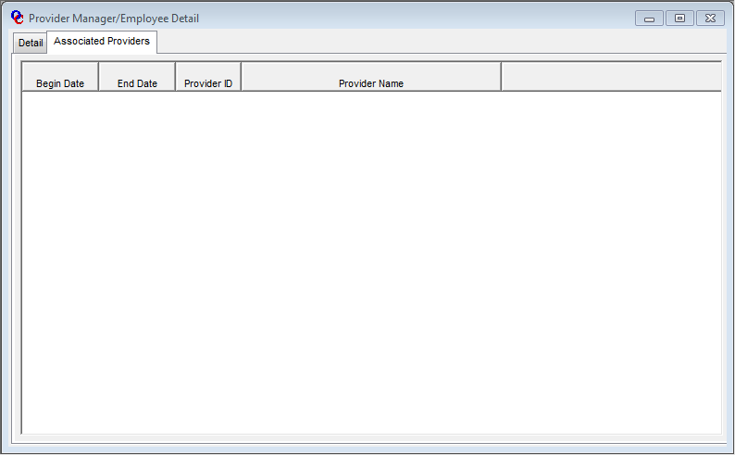
NEW MEXICO OMNICAID MMIS PROVIDER SUBSYSTEM
WINDOW SPECIFICATION
PROVIDER MANAGER/EMPLOYEE DETAIL FUNCTIONAL GROUP
ASSOCIATED PROVIDERS TAB PAGE

Field Name | Table  Column Name | Table Name | Format | Prot  (A,C,N) | Req  (A,C,N) | Std Edits | Specifications | Note  Ref
Begin Date | P_OWNEMP_BEG_DT | P_OWNEMP_XREF_TB | DATE | A | N | N/A | Format is MM/DD/YYYY
End Date | P_OWNEMP_END_DT | P_OWNEMP_XREF_TB | DATE | A | N | N/A | Format is MM/DD/YYYY
Provider ID | P_ID | P_OWNEMP_XREF_TB | X(08) | A | N | N/A
Provider Name | P_NAM | P_PROV_TB | X(45) | A | N | N/A
 | P_SORT_NAM | P_PROV_TB | X(45) | A | N | N/A

_______________________________________________________________________________________________________________________________

LEGEND: For Prot and Req: A = Always For Std Edits: D = Date Edit V = Valid Value Edit
C = Conditionally N = Numeric Edits S = System Generated
N = Never

